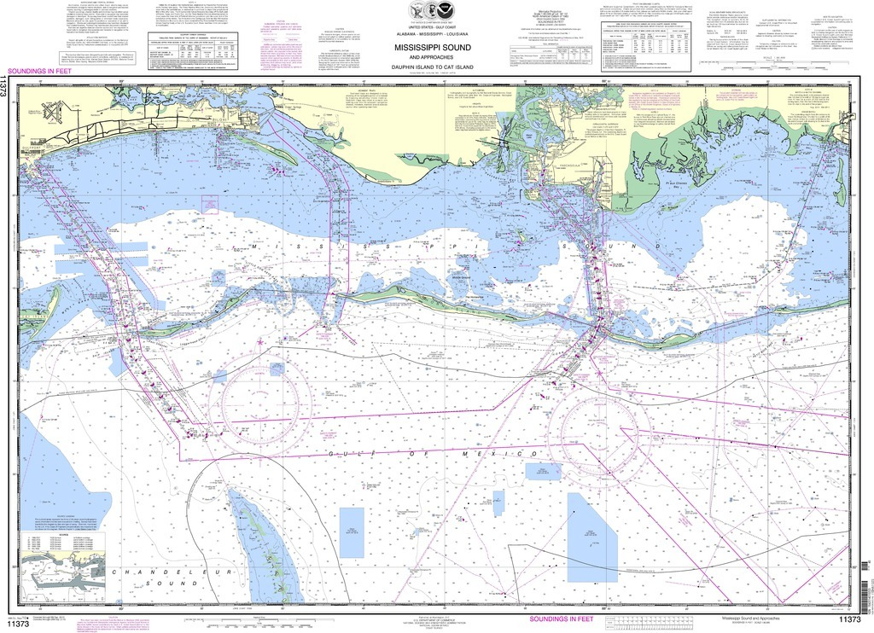

4-D Cube

User and Data Guide
2020

USM
Division of Marine Science



Web-based tool providing simulated and observed marine conditions in the Mississippi Sound and nearby waters

USM’s 4-D Cube is a web accessible interactive marine data tool tailored for a test area in the Mississippi Sound and Gulf of Mexico. The Cube provides parameter fields and vertical profiles from hydrodynamic models, satellites and field observations.

This guide provides an overview of the user interface and data access, followed by details on the data displayed.

4-D Display Fields
Parameter | Unit | Resolution | Input source
Current Speed | knots | varies with input source | HYCOM, NCOM, NGOFS, NEGOFS, AMSEAS, RADAR
Temperature | deg F | varies with input source | HYCOM, NCOM, NGOFS, NEGOFS, AMSEAS
Salinity | psu | varies with input source | HYCOM, NCOM, NGOFS, NEGOFS, AMSEAS
Surface Elevation | ft | varies with input source | HYCOM, NCOM, NGOFS, NEGOFS, AMSEAS
Chlorophyll | mg/m³ | 750 m | SNPP-VIIRS
Depth | ft | 154 m | NOAA Coastal Relief bathymetry

Accessing Data
The 4-D cube is available to external users at oceancube.usm.edu . Archived data (previously generated model web pages) are available for display under the ‘Archive’ tab. The “Cube Data” tab displays the most recent output for the USM range.

To begin accessing and displaying data, users will select a model type in the “Cube Data” drop down menu.
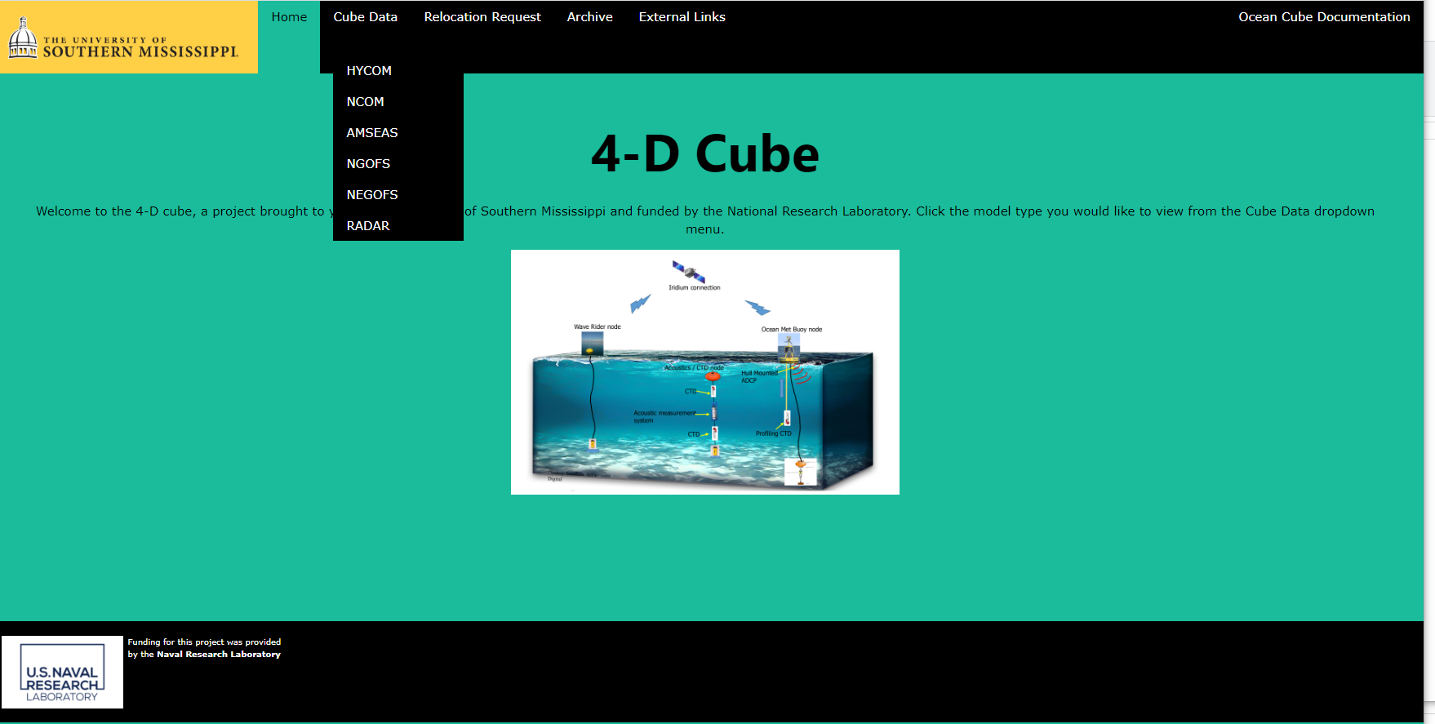

After choosing a model selection under “Cube Data”, a client-side interactive display is generated (loading time typically less than 1 minute). 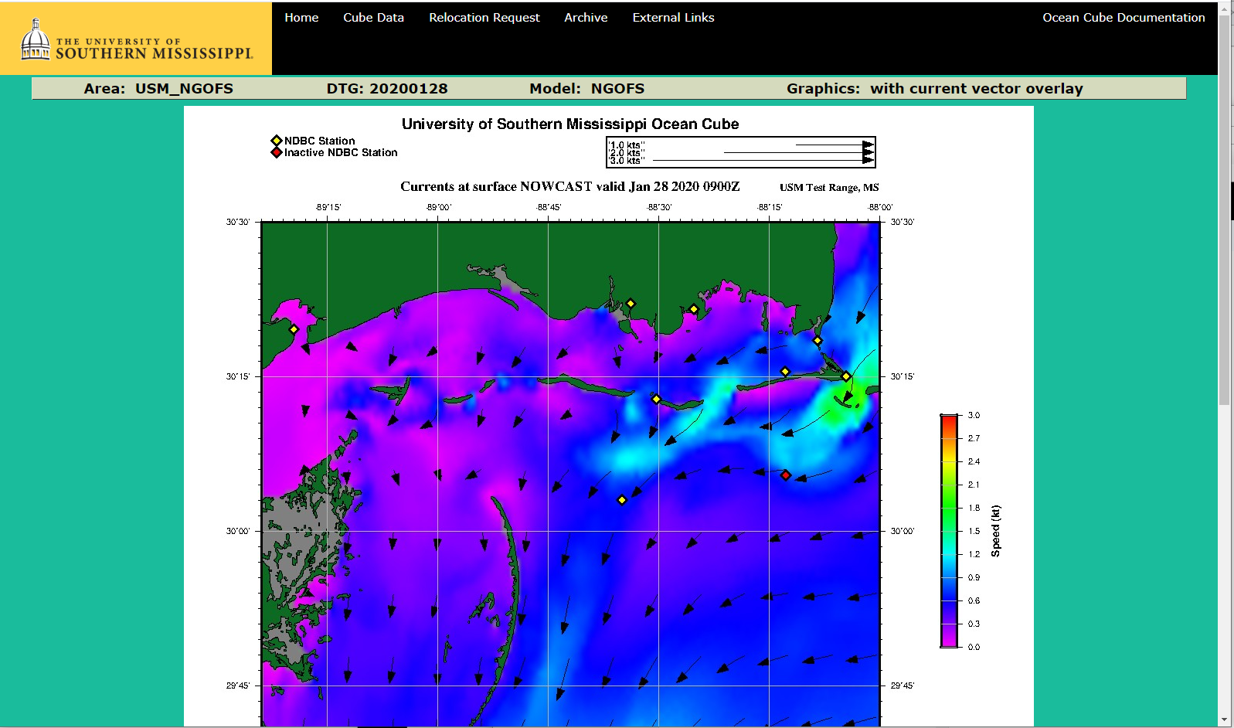

The Cube can be set to display depth slices of speed, temperature, salinity, surface elevation, chlorophyll or bottom depth selected by the user.

Forecasts of each parameter are dependent on the selected model time step. The forecast time steps (TAUs) are displayed by advancing the animated frames.

Depth slices are superimposed with current vectors. Holding the mouse over the image will display latitude, longitude and model estimates, chlorophyll from the latest satellite data and depth at that location.

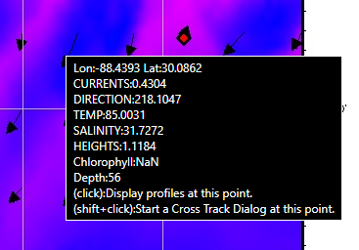

Users may ‘click’ at any grid point on the displayed parameter slice to display vertical profiles of model output at that grid point at that time. Vertical profiles include current speed, temperature, salinity and sound speed.

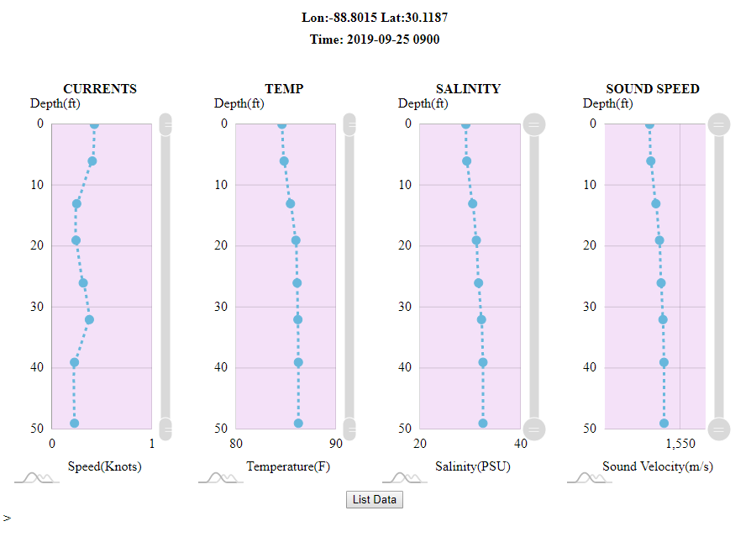

Optionally while hovering over a point in the display, the user may select a shift-click to start a cross track dialog. If started, a dialog box opens displaying a latitude/longitude start point. By clicking on a second location, the user opens transect plots of each model parameter with depth along the selected track (a shift-click at the second point cancels the cross track dialog).

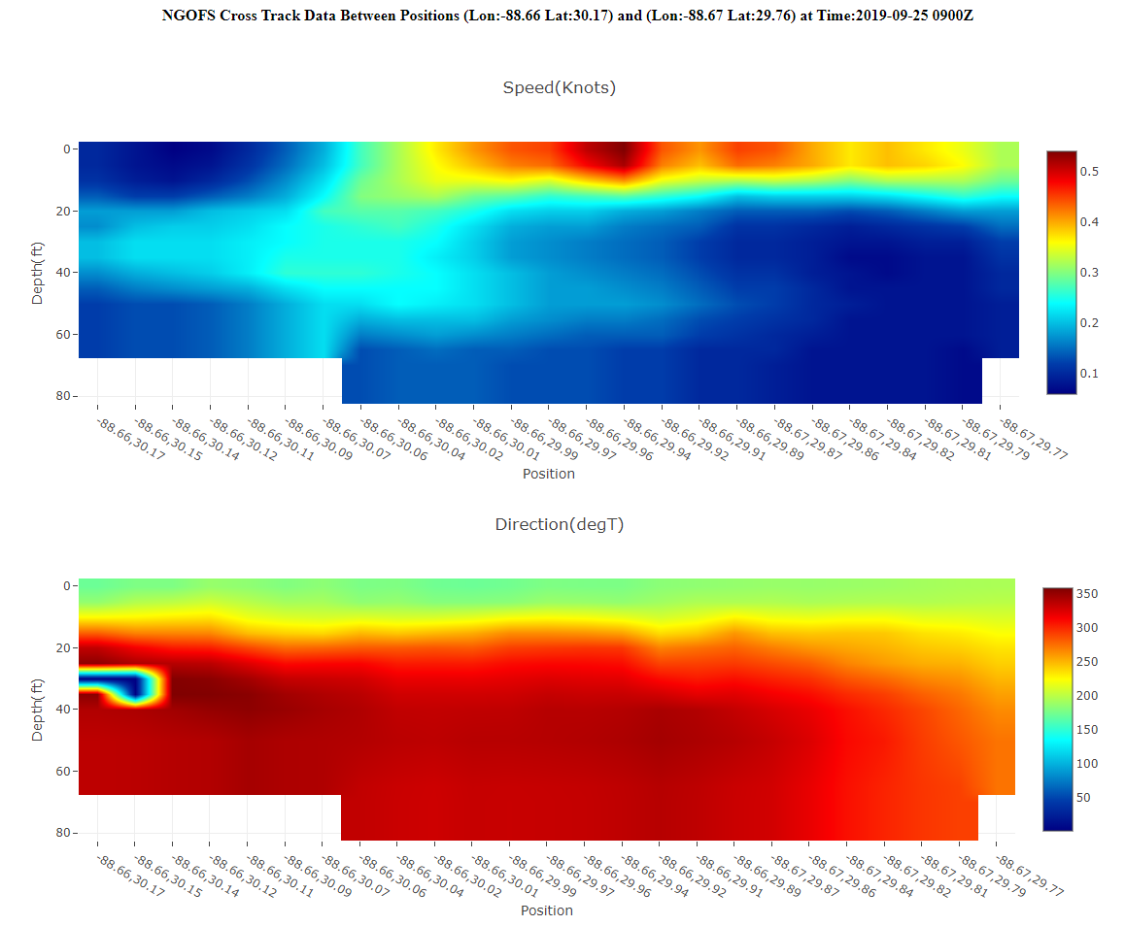

From the cross track dialog box, the user can enter a source frequency and source depth to display transmission loss across the chosen transect.
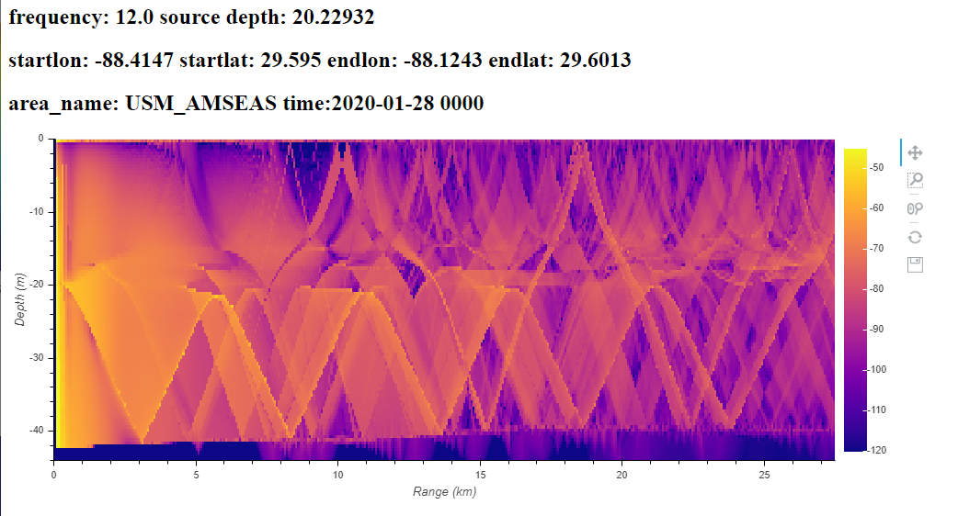

Selecting the 3-D View button below the display allows the user to view all available depth slices for the selected model-parameter simultaneously. Users can rotate the 3-D view using a mouse or trackpad.

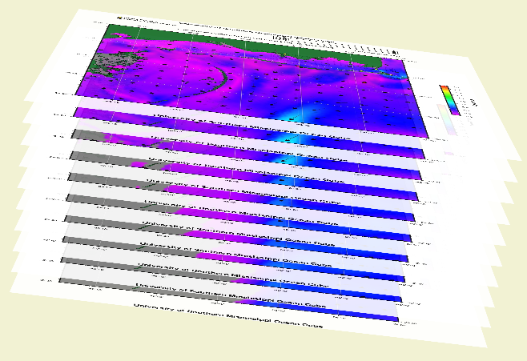

The depth drop down menu alters the 3-D view so that the selected depth is displayed.

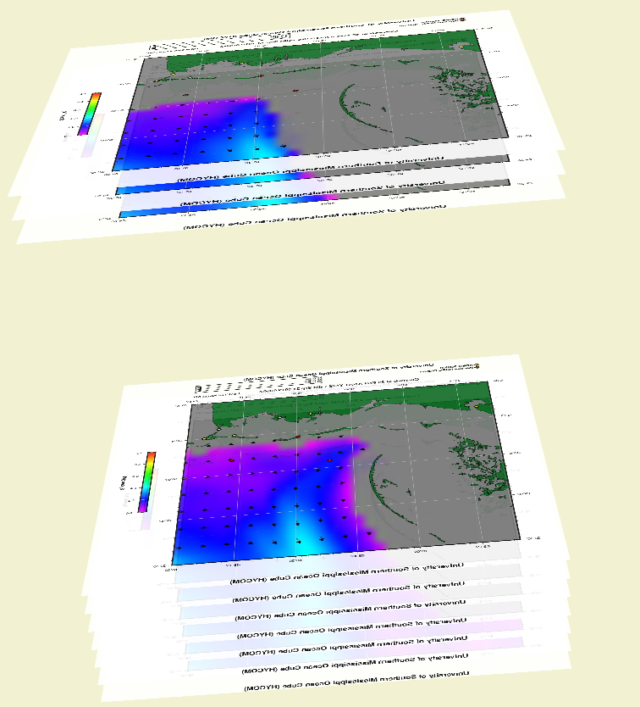

The locations of reference points, typically National Data Buoy Center (NDBC) stations, are displayed on the slices. The model estimates at the reference point location for the currently displayed time slice are available on the user interface page in tabular form. Users may select a reference point by clicking the reference point indicator to view a time series of measurements. Users may also shift-click to obtain data from the reference point website (NDBC station website if available).

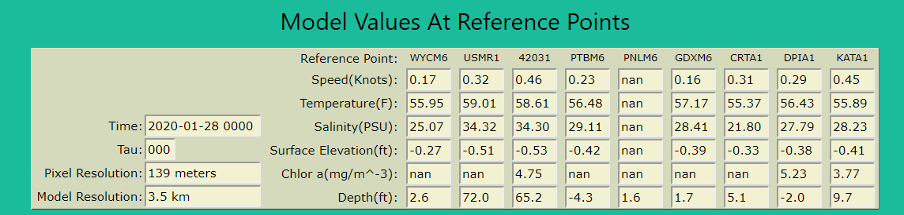

Relocation Request
The Region Request tab allows for a submission of a request for a one-time building of the web pages for a geographic region other than the USM-Range. The user enters his email address, an area ID (1 to 5 alphanumerical characters and ‘_’ allowed with no spaces), the geographic extent (a bounding rectangle defined by the North, South, East, and West fields in decimal degrees), the desired model(s) to extract data, and up to 9 depth layers (0 or surface is assumed). Once the form is completed a submit button will begin the generation of the web pages for the relocated area in the Gulf of Mexico and an email with the link for each selected model will be sent to the user email address upon completion. This function is currently in BETA and is not guaranteed to perform to expectations.
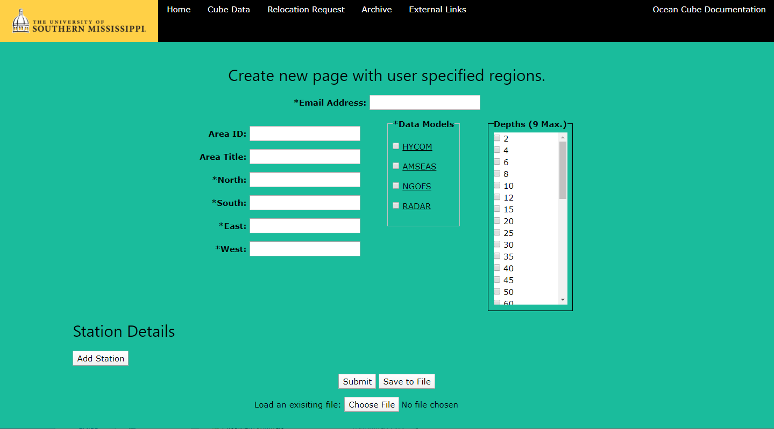

Station Details
The user can add more stations to the model. By clicking on the Add Station button additional fields will be displayed in the form. Clicking on the Add Station button again will add more fields for another station. If the user decides a station is not needed, click on the Remove Station button associated with each station.

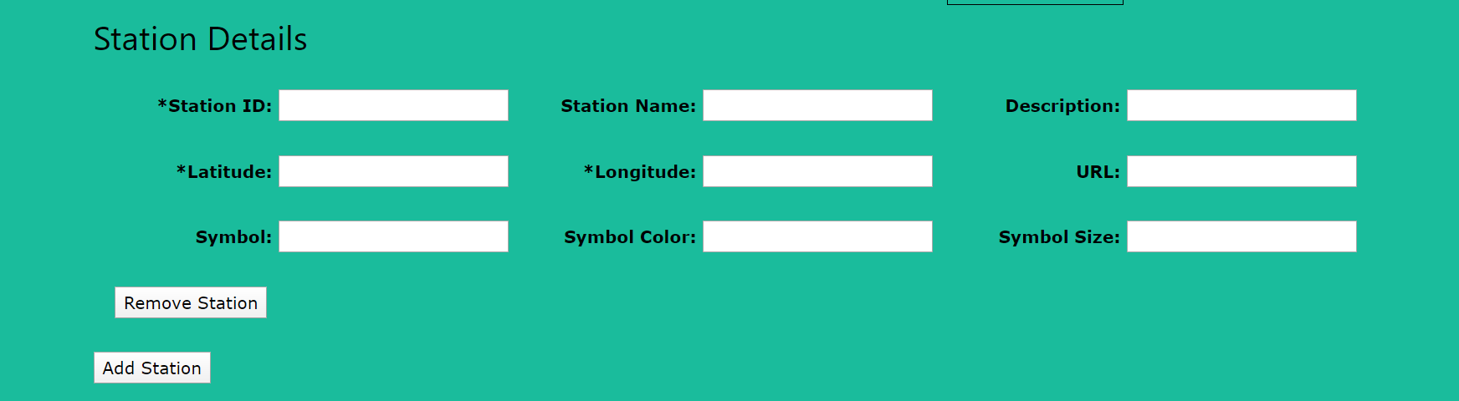

Save to File
The user can save the model configuration data local to their system by clicking on the Save to File button. The model configuration is saved in a JSON format and can be edited in a standard text editor.

Upload a File
The user can upload a model configuration file by clicking on the Choose File button. The file needs to be in a JSON format. If the user is unfamiliar with the layout of the JSON file, a file can be downloaded by clicking on the Save to File button and be used as a template.

Input Data

With the exception of acoustic transmission loss, all data displayed on the Cube is obtained from external sources chosen to provide trusted and reliable comprehensive coverage of the region. Once received, data/output are geographically extracted and then the Generic Mapping Tool software (GMT) from the University of Hawaii’s School of Earth Science and Technology is used to generate data graphics.

HYDRODYNAMIC OCEAN MODELS

Output from four widely used ocean models are extracted and displayed. Differences in model output stem from algorithm differences between models, varying horizontal grid spacing, utilization of differing depth coordinate systems to solve the models, temporal resolution and discrepancies in boundary conditions and inputs. A brief description of each model is provided here as well as source websites in Table XX for more details.

All available observed, nowcast and forecast time steps are obtained from each model.

HYCOM (Hybrid Coordinate Ocean Model) is the Naval Oceanographic Office’s operational ocean model. HYCOM is named after its hybrid vertical coordinate system that uses the layered continuity equation to transition between sigma, isopycnal and z depth layers. The operational version of HYCOM provides the boundary conditions for the HYCOM experiment GOMu0.04/expt_90.1m000 selected for the CUBE. This HYCOM experiment is run with HYCOM version 2.2.99G-i for the Gulf of Mexico. The solution is calculated with forcing from the Navy Global Environmental Model (NAVGEM) and tidal forcing on 36 vertical layers. Satellite and in situ observations are assimilated using the Navy Coupled Ocean data Assimilation system (NCODA). Each nowcast and forecast is interpolated to a 1/25° horizontal and 40 standard z-level grid for distribution. Further information can be obtained from the HYCOM.org site: https://www.hycom.org

NCOM (Navy Coastal Ocean Model) was the operational global ocean model for the Navy prior to HYCOM. Regional NCOM models are now used by the Fleet Numerical Meteorology and Oceanography Center (FNMOC) and for scientific research. In addition to changes in coding, NCOM differs from HYCOM in that it uses only sigma and z depth layers as its vertical coordinate system. The solution used by the Cube is extracted by the Naval Research Laboratory exclusively for the Cube project. The extraction is from an experiment focusing on the Gulf of Mexico with NCODA data assimilation. This experiment has been running since 2012 and is calculated on a 49 vertical layer grid with 1 km horizontal resolution. Forcing is from the Coupled Ocean/Atmosphere Mesoscale Prediction System (COAMPS) with boundary conditions set by the operational global HYCOM. In general, these data are available about 2 days after the model run. These data are not available to the public and a special cut-out of the USM-RANGE is provided to USM via an arrangement with the Naval Research Laboratory.

AMSEAS (American Seas) is a lower resolution (1/8° horizontal) regional NCOM model (Region 1) and has the advantage of data availability within hours of the model run (as well as coverage for the entire Gulf of Mexico). The data are distributed via a THREADDS Data Server operated by NOAA. Further information can be obtained from the NOAA site: https://www.ncdc.noaa.gov/data-access/model-data/model-datasets/navoceano-ncom-glb

NGOFS (Northern Gulf of Mexico Operational Forecast System) is a model that is run and maintained by NOAA’s Center for Operational Oceanographic Products and Services (CO-OPS). The model has been operational since 2012 and is expected to be run as a higher resolution model when merged with NEGOFS and NWGOFS in the future. NGOFS runs on 41 vertical sigma layers and on an irregularly spaced horizontal grid that allows variable resolution of 150m to 11 km. The model is interpolated to a 0.1-degree regularly spaced grid for distribution. NGOFS generates 6-hour nowcasts and 48-hour forecast guidance. OceanCube downloads these grids from a NOAA server at up to four times daily for runs at 3:00, 9:00, 15:00 and 21:00. Further information can be found under the Gulf of Mexico section of the following web site: https://tidesandcurrents.noaa.gov/models.html

NEGOFS (North Eastern Gulf of Mexico Operational Forecast System) was developed, along with a similar region in the western gulf, to allow finer resolution near coastlines and geographic features. Like NGOFS it is run and maintained by NOAA’s Center for Operational Oceanographic Products and Services (CO-OPS). NEGOFS runs on 20 vertical sigma layers and on an irregularly spaced horizontal grid that allows variable resolution of 45m to 2.2 km. The model is interpolated to a 0.05-degree regularly spaced grid for distribution. NEGOFS generates 6-hour nowcasts and 48-hour forecast guidance. OceanCube downloads these grids from a NOAA server at up to four times daily for runs at 3:00, 9:00, 15:00 and 21:00. Coverage and specific data requests can be obtained at: https://opendap.co-ops.nos.noaa.gov/ofsdataagg/negofs.html

Name | Source | Horizontal Resolution | Vertical Resolution | Time Step | Forecast
HYCOM | hycom.org  experiment 90.1m000 | 3.5 km | 36 z, sigma and isopycnal layers | 3-hour | 120 hours
NCOM | NRL-Stennis | 1 km | 13 z and sigma layers | 3-hour | 144 hours
AMSEAS | Ncdc.noaa.gov | 3.5 km | 13 z and sigma layers | 3-hour | 96 hours
NGOFS | tidesandcurrents.noaa.gov | 1 km  calculated at 150 m – 11 km | 41 sigma layers | 1-hour | 72 hours
NEGOFS | tidesandcurrents.noaa.gov | 0.5 km  calculated at 45 m – 2.2 km | 20 sigma layers | 1-hour | 72 hours

OTHER

In addition to model solutions, reference points, satellite observations and acoustics contributions to the Cube’s mission to provide comprehensive regional coverage,
the Cube obtains high frequency radar of current speed and direction from NOAA. The currents are measured hourly at 6 km resolution. GMT is used to plot vector fields of the currents, which are then superimposed on a scaled color display of the radar-derived surface currents.

Satellite derived chlorophyll (surface only) is obtained from CoastWatch and displayed when atmospheric conditions allow at least 10% coverage in the Cube region. The chlorophyll estimates are made via the OCL3 equation to calculate chlorophyll concentration from water leaving radiance. The Cube displays surface chlorophyll derived from measurements made by the Visible Infrared Imaging Radiometer Suite (VIIRS) on board the Suomi National Polar-orbiting Partnership (S-NPP) satellite.

The BELLHOP beam tracing model is run on demand by the user to predict transmission loss across a selected transect. A Fortran-based version of the BELLHOP software is housed on a USM server. The input to the software includes bathymetry, model estimates of sound speed and source depth and frequency.

Reference point locations are mapped to model displays. At each reference point location, the model estimate for that reference point is provided. The Cube does not download reference point data directly. For reference point data a link to the NDBC station is provided on the displayed map.

Name | Source | Horizontal Resolution | Vertical Resolution | Frequency
RADAR | hfradar.ndbc.noaa.gov | 6 km | surface | hourly
SNPP-VIIRS | coastwatch.noaa.gov | 750 m | integrated surface | daily  (when at least 10% of area is available)
Bathymetry | ngdc.noaa.gov | 154 m | bottom depth
BELLHOP | Cube server |  |  | on demand

In Situ

Name | Source | Type | Measurements  Available | Frequency
WYCM6 | ndbc.noaa.gov | station | water level, meteorological | 6 minute
USMR1 | ndbc.noaa.gov | buoy | water temperature, water level, meteorological, salinity, currents at depth | hourly
NOAA-42031 | ndbc.noaa.gov | buoy | INACTIVE | INACTIVE
PTBM6 | ndbc.noaa.gov | station | water temperature, water level, meteorological | 6 minute
PNLM6 | ndbc.noaa.gov | station | water temperature, water level | 6 minute
GDXM6 | ndbc.noaa.gov | station | meteorological | 15 minute
CRTA1 | ndbc.noaa.gov | station | water temperature, salinity, oxygen, turbidity and meteorological | 30 minute
DPIA1 | ndbc.noaa.gov | station | meteorological | hourly
KATA1 | ndbc.noaa.gov | station | meteorological | 30 minute

External Links
The 4-D cube start page includes the tab “External Links” that provides continuously updated links to data sources, regional background and relevant complementary data. As of this printing, the links include:

National Data Buoy Center (Buoy Data/CMAN)
Mississippi Sound and Approaches (Chart 11373 - OceanGrafix.com)
Mississippi Department of Marine Resources (USGS)
NOAA Northern Gulf of Mexico Operational Forecast System (NGOFS)
BOEM Northern Gulf of Mexico Bathymetry Grid from 3D Seismic
Gulf of Mexico Coastal Ocean Observation System Data Portal
Gulf of Mexico Coastal Ocean Observation System Gliders:GANDALF
NOAA Harmful Algal BloomS Observing System
Lake Pontchartrain Basin Foundation Hydrocoast

