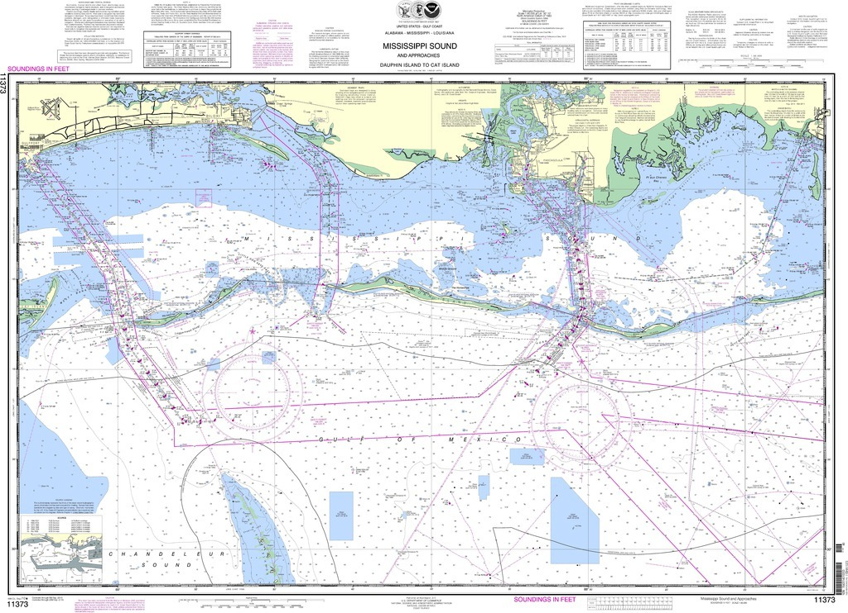

Coastal CUBEnet

User and Data Guide

Web-based tool providing simulated and observed marine conditions in the Mississippi Sound and nearby waters
2022

USM
Division of Marine Science


USM’s Coastal CUBEnet is a web accessible interactive marine data tool tailored for a test area in the Mississippi Sound and Gulf of Mexico. Since its original deployment, it has been expanded to incorporate additional areas which include the Mississippi River outlet, the Mobile Bay area and an area off the west coast of Florida. The CUBEnet provides parameter fields and vertical profiles from hydrodynamic models, satellites and field observations.

This guide provides an overview of the user interface and data access, followed by details on the data displayed.

CUBEnet Model Display Fields
Parameter | Unit | Resolution | Input source
Current Speed | knots | varies with input source | HYCOM, AMSEAS, NGOFS2, NWPS, COAWST
Temperature | deg F | varies with input source | HYCOM, AMSEAS, NGOFS2, COAWST
Salinity | psu | varies with input source | HYCOM, AMSEAS, NGOFS2, COAWST
Surface Elevation | ft | varies with input source | HYCOM, AMSEAS, NGOFS2, NWPS, COAWST
Wind Speed | knots | varies with input source | NWPS, COAWST
Wave Height | ft | varies with input source | NWPS
Swell Height | ft | varies with input source | NWPS
Wave Period | seconds | varies with input source | NWPS
Chlorophyll | mg/m³ | 4 km | SNPP-VIIRS
Depth | ft | 154 m | NOAA Coastal Relief bathymetry

Accessing Data
The Coastal CUBEnet is available to external users at oceancube.usm.edu (131.95.7.148). The 4-D Cube home page can be launched from this site by clicking on the “Modeling” link in the home page graphic or in the text above the graphic. Similarly, the “Data” link in the graphic or the text immediately above the graphic can be used to link to oceancube.usm.edu:3001 which provides a series of graphic displays of instrumentation data using the Grafana software package. Additional features such as access to model data, external web sites and documentation are provided using the links along the top banner. These links are available from all 4-D Cube web pages.

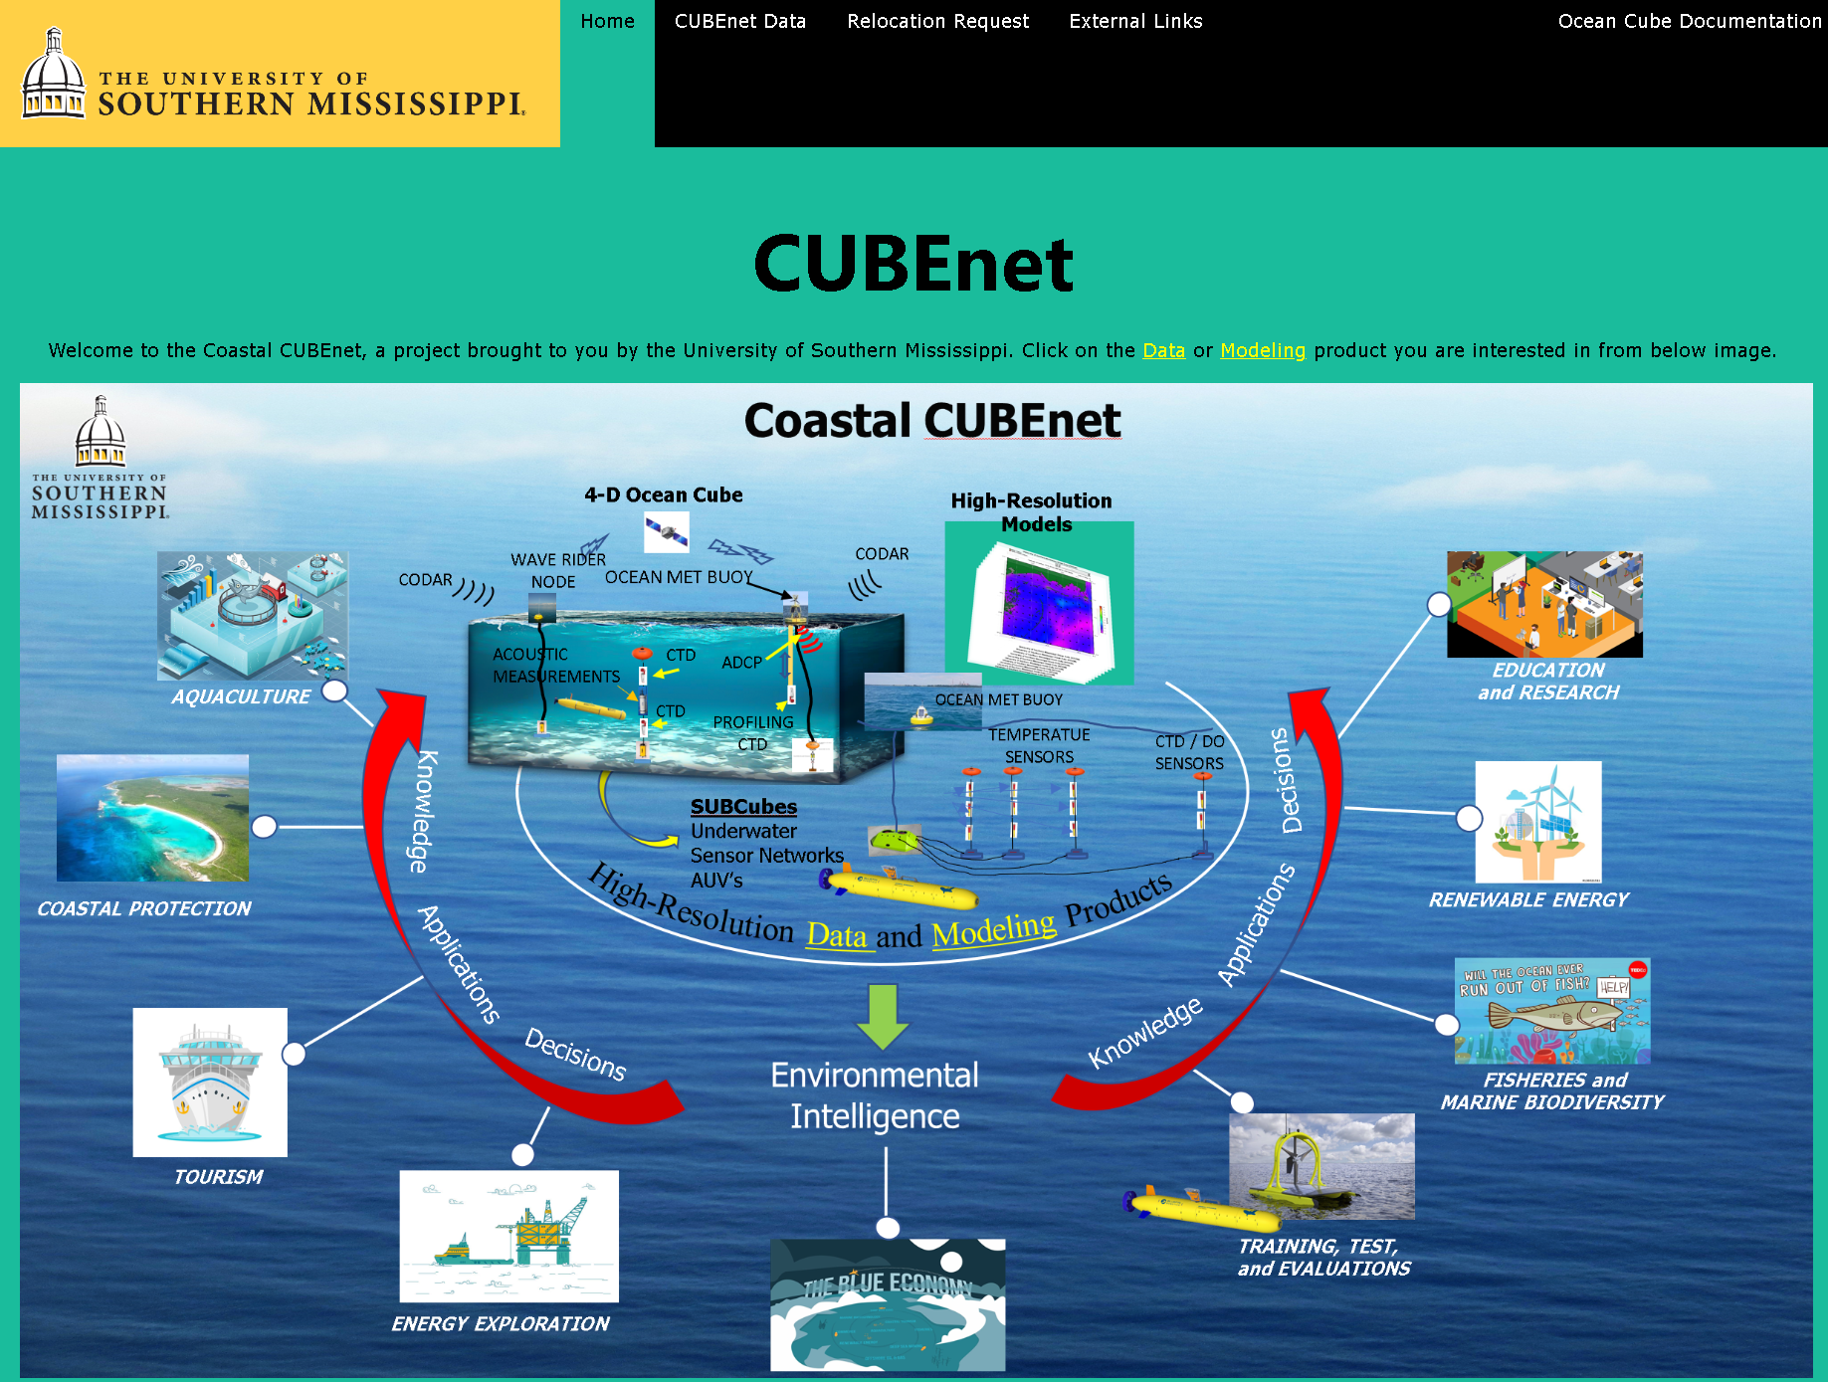

To begin accessing and displaying model data, users will select “Models” in the “CUBEnet Data” drop down menu. Alternatively, from this dropdown menu, the user may select “Observations” which will link to the Grafana graphic display of near real time acquired instrumentation data.

After choosing “Models” under “CUBEnet”, the page below is displayed which includes the areas that are available for the various models. Currently there are up to 4 areas available:
MSR-Mississippi River Outlet,
USM-University of Southern Mississippi Test Range,
MBL-Mobile Bay, and
WFL-West Florida.

The models that are currently available include:
HYCOM- Hybrid Coordinate Ocean Model;
AMSEAS- American SEAS;
NGOFS2- Northern Gulf of Mexico Operational Forecasting System;
NWPS- Nearshore Wave Prediction System; and
COAWST- Coupled Ocean Atmosphere Wave Sediment Transport.

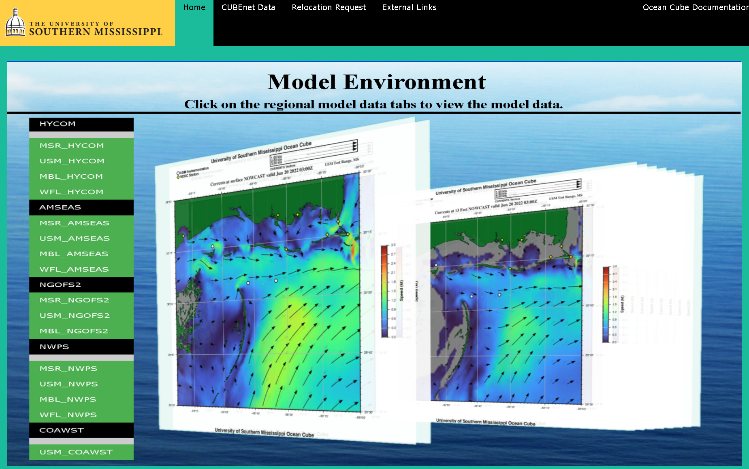

After clicking on an area link for a model, a client-side interactive display is generated (loading time typically less than 1 minute).

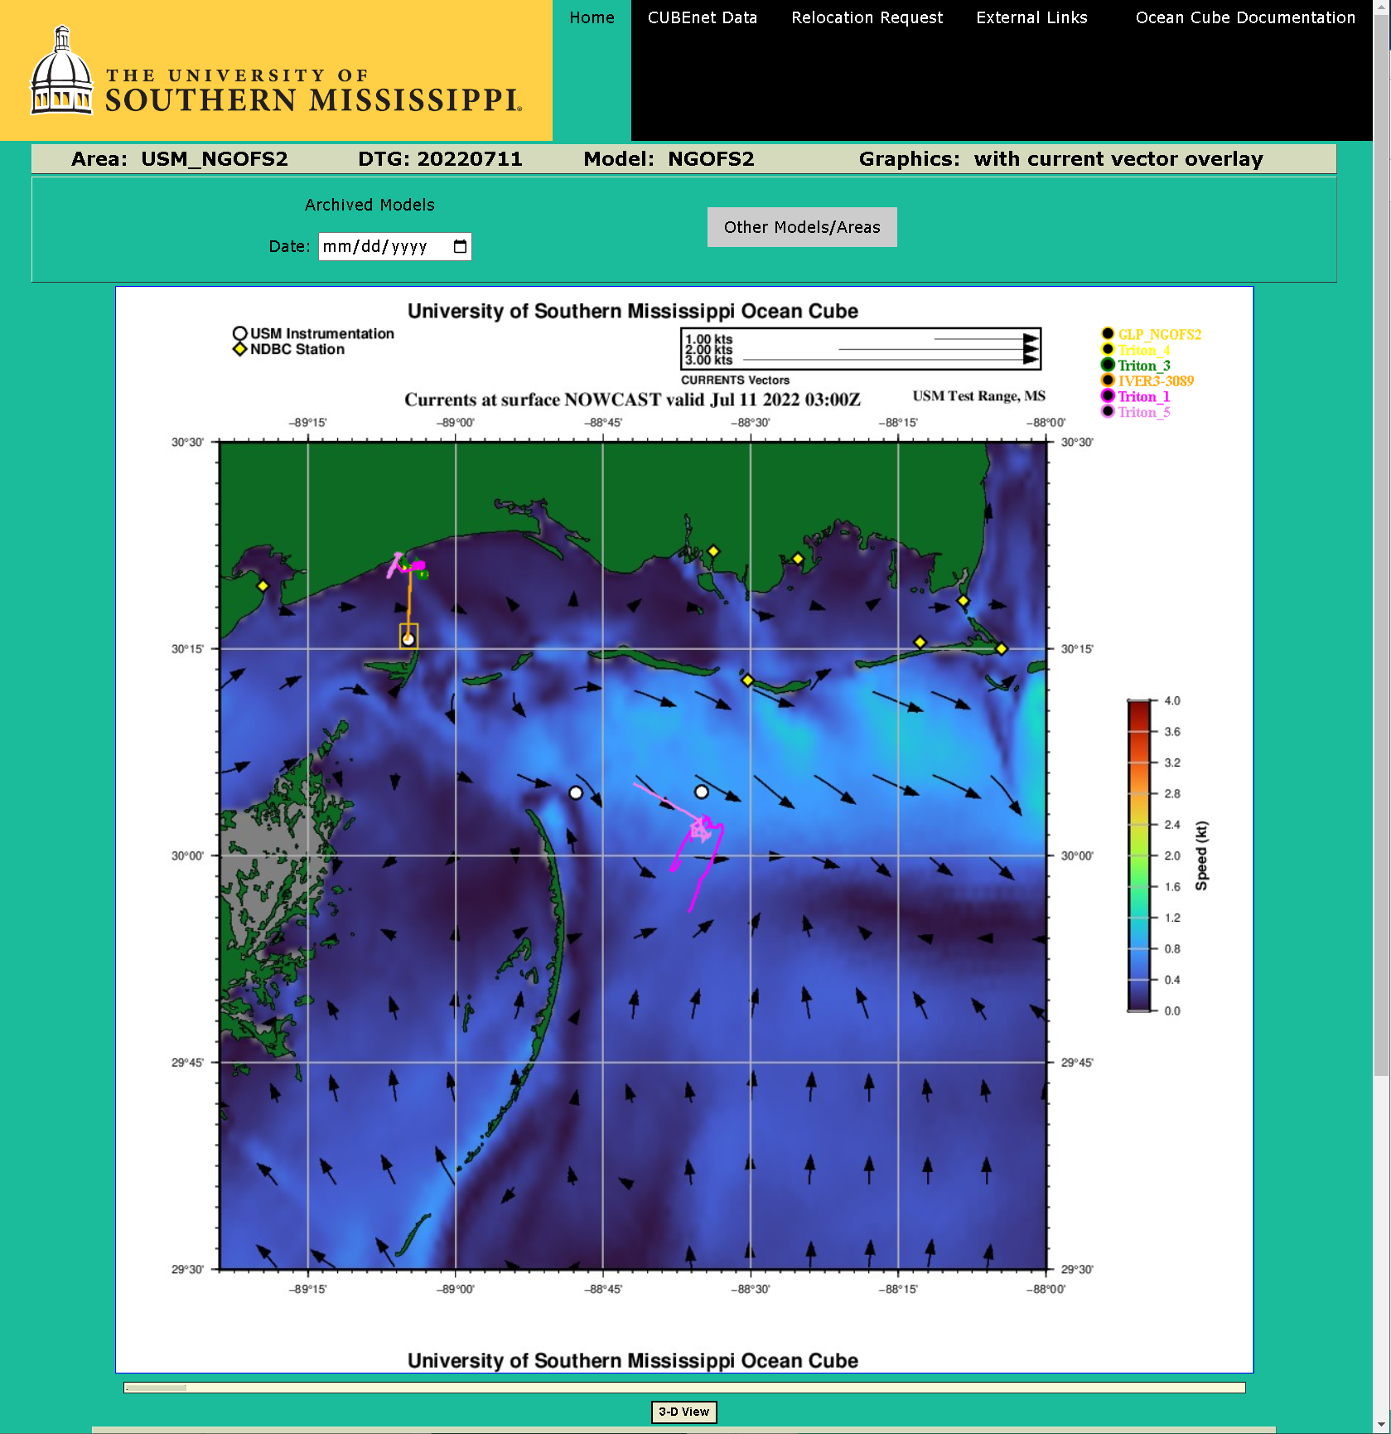

Archived model data for the displayed model and area can be retrieved and examined through the selection of a date in the “Archived Models” section above the graphic. By selecting a date, a list of links to archived web interfaces for that model type appear on the page.

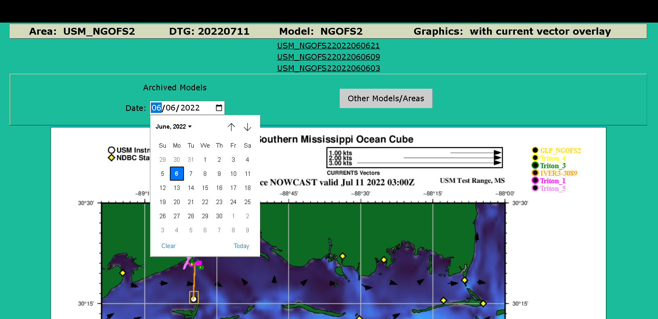

Access to other models/areas can be rapidly linked to through the dropdown menu that is accessible with the “Other Models/Areas” button. In addition to the other models, links to the satellite and high frequency radar observations for the areas are available.
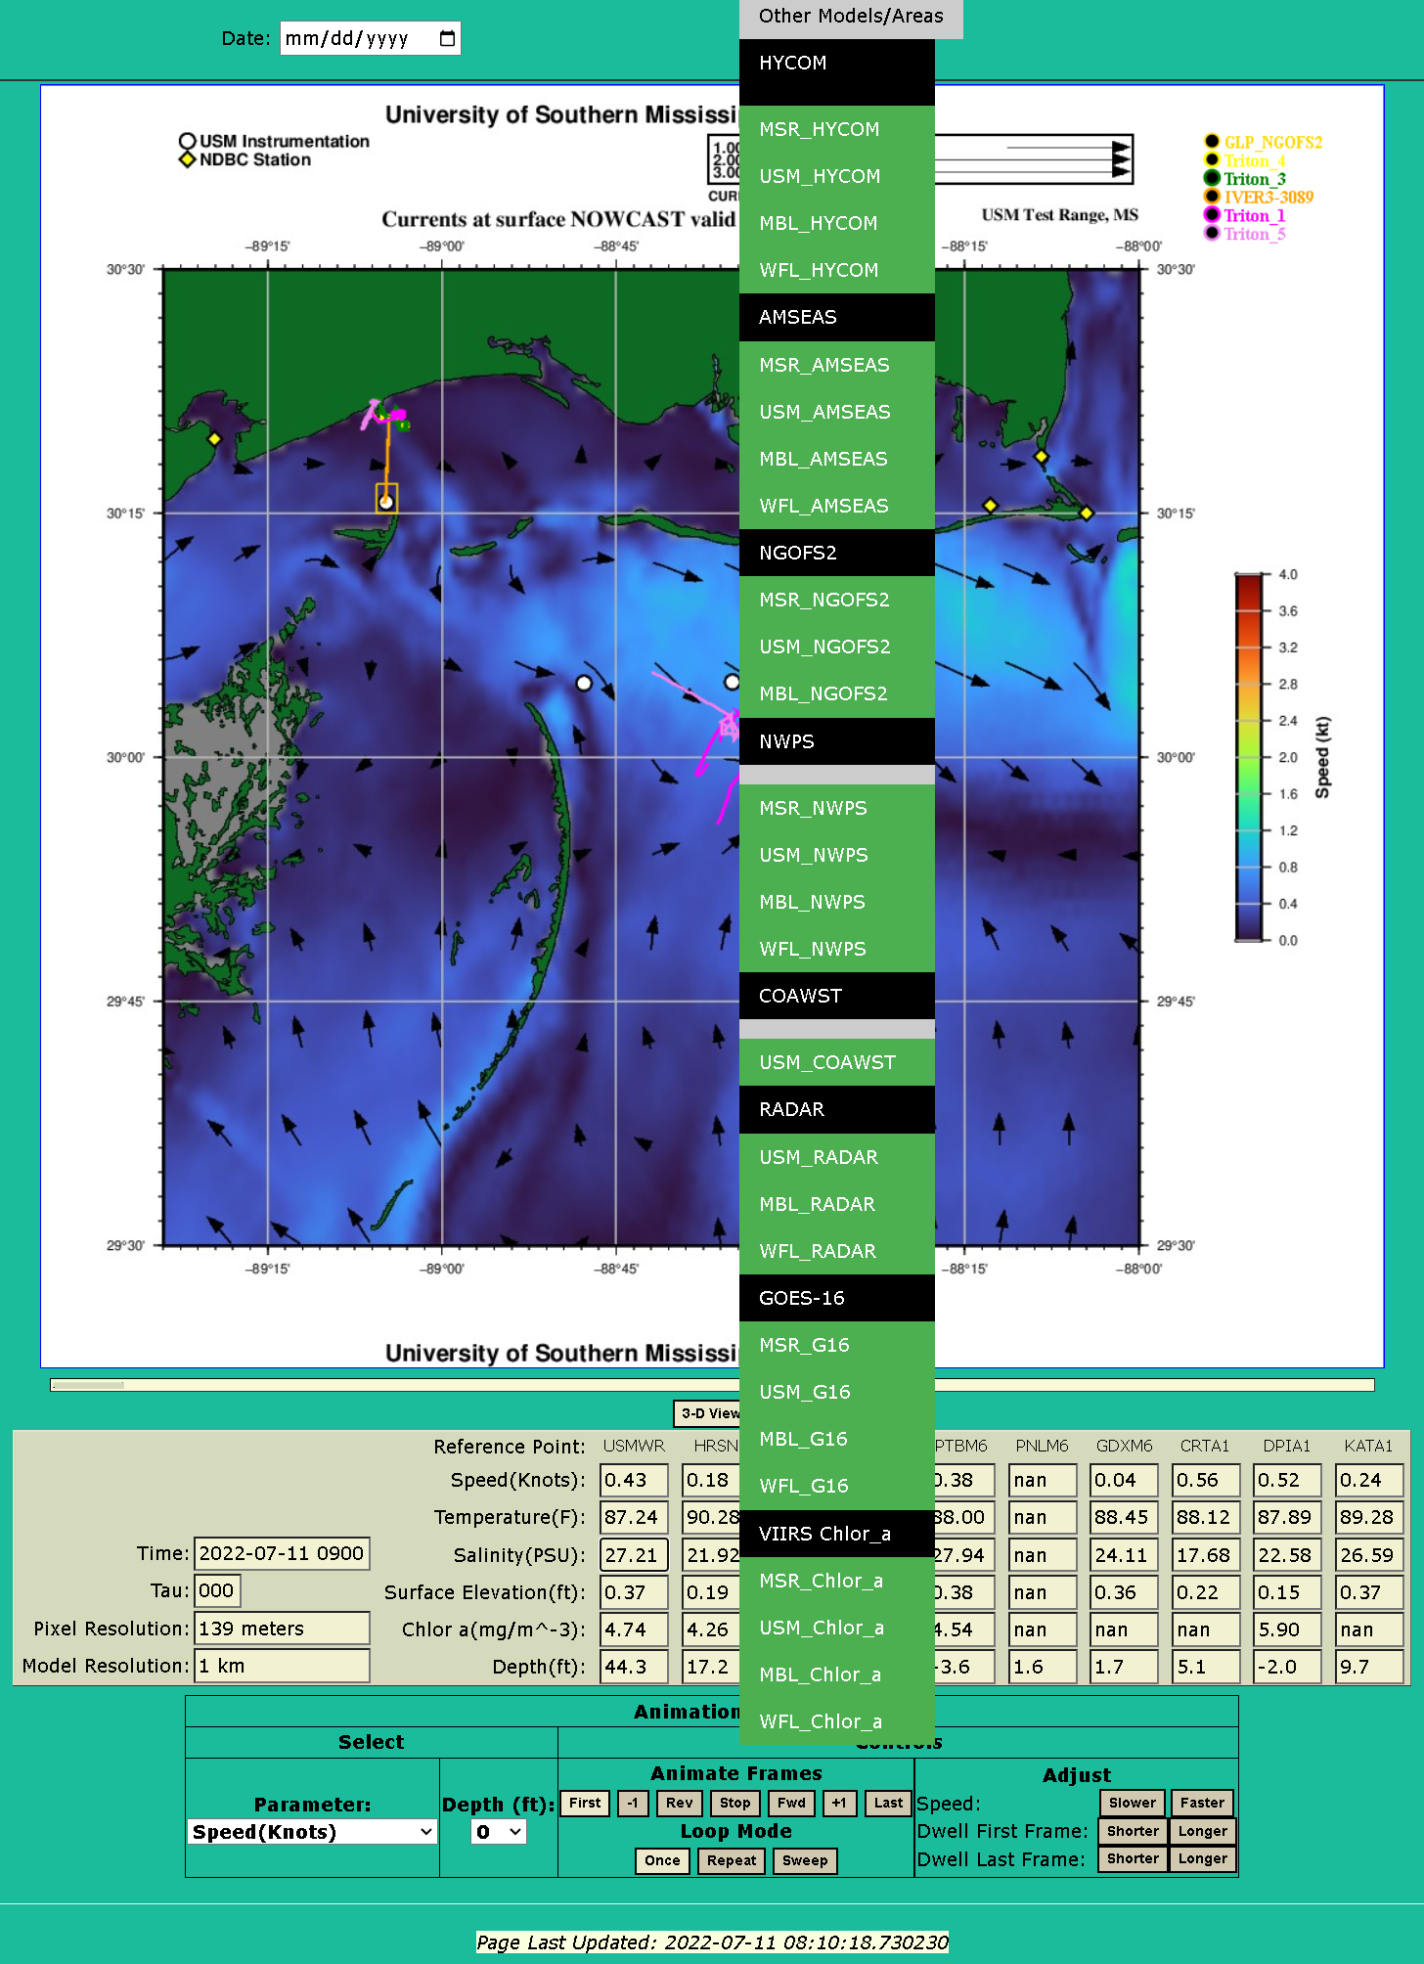

The Cube can be set to display depth slices of speed, temperature, salinity, surface elevation, chlorophyll or bottom depth selected by the user.

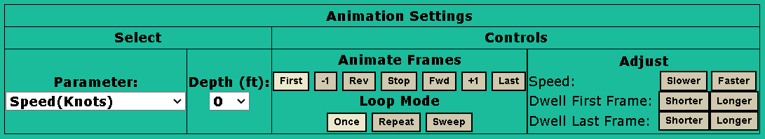

Forecasts of each parameter are dependent on the selected model time step. The forecast time steps (TAUs) are displayed by advancing the animated frames.

Depth and surface slices are superimposed with current vectors with the exception of NWPS and COAWST Winds which are superimposed with wind vectors. Holding the mouse over point (hover) in the area graphic will display latitude, longitude and model estimates at that location.

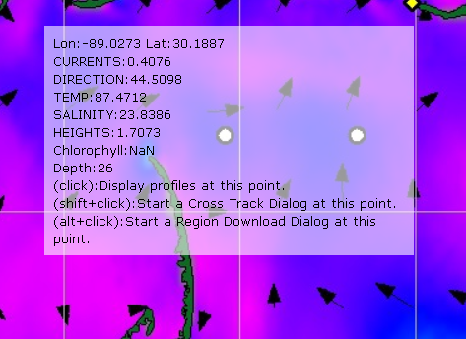

Users may ‘click’ at any grid point on the displayed parameter slice to display vertical profiles of model output at that grid point. Vertical profiles include current speed, temperature, salinity and sound speed.

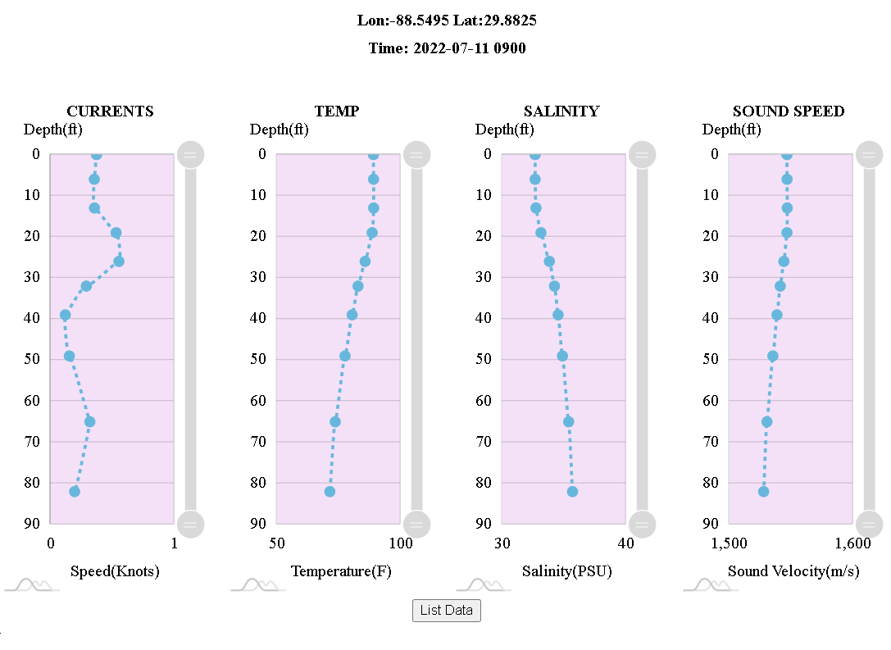

By clicking on the “List Data” button, a tabular display of the profile data is displayed.

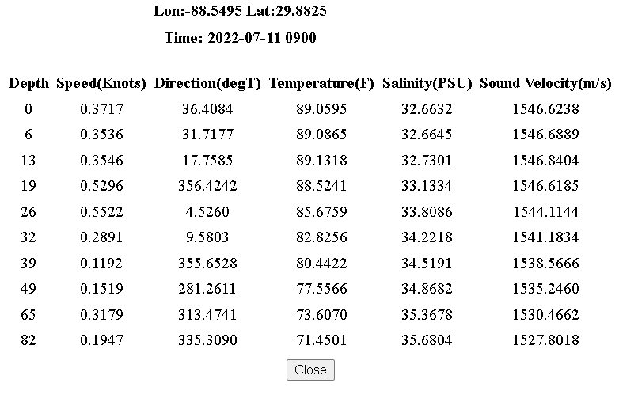

As a second option, the user is directed to shift-click to start a cross track dialog. If started, a dialog box opens displaying a lat-lon start point. By clicking on a second location, the user opens transect plots of each model parameter with depth along the selected track. The user may optionally enter the start and end coordinates in the dialog box and click the “Plot Cross Track” button. As shown below, the user may move the mouse over the graphs to display the data values at each location.

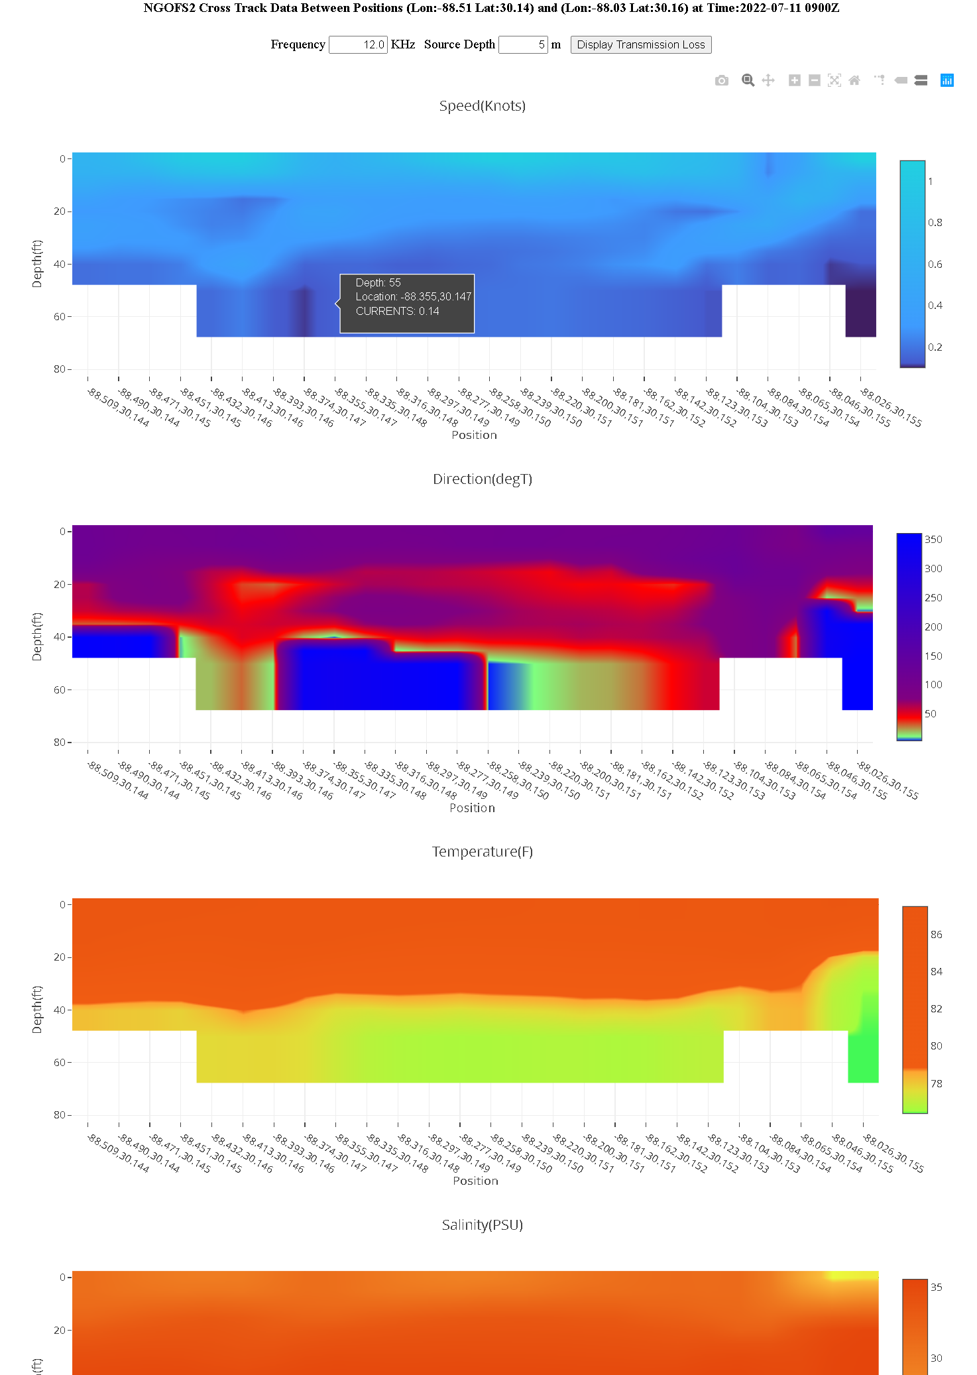

From the cross track dialog box, the user can enter a source frequency and source depth to display transmission loss across the chosen transect.

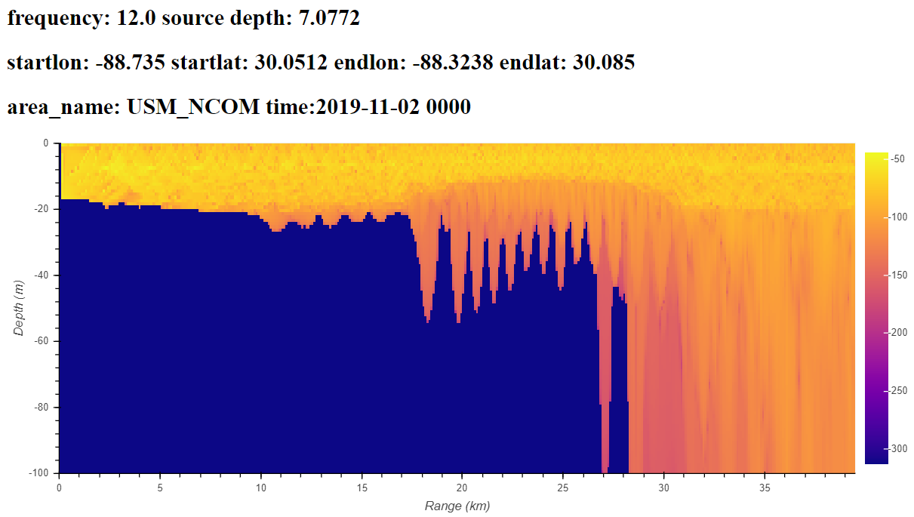

As a third option, the user is directed to alt-click to start a data extraction dialog. When clicked, a dialog box opens displaying a start point latitude and longitude. The user may optionally set the number of samples along the Y-Axis and X-Axis to determine the number of interpolated model points to extract (default is a 10 by 10 grid). By clicking on a second location (or entering an end position latitude and longitude and clicking on the “Extract Data for Region” button), the user opens a listing of interpolated model parameter values for each depth within the selected region.

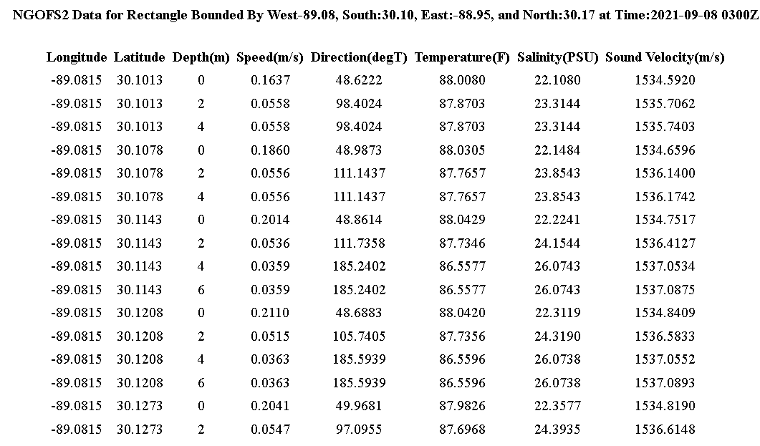
.
.
.
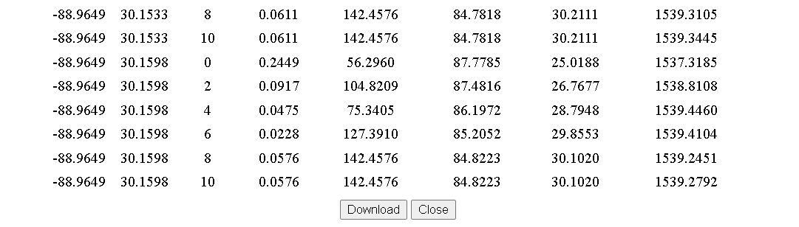
Clicking on the “Download” button will create an ASCII Comma-Separated Values (.csv) file of the displayed listing capable of being opened by Microsoft Excel or any text editor.

On the model display, there may be several pre-positioned reference points plotted within the area. Moving the mouse to a reference point and hovering over it provides options for that point.

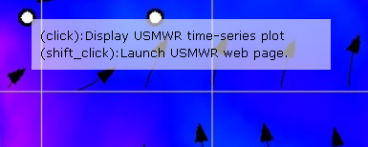

A click on the point will launch a dialog box featuring options for display of several time series graphics for model parameters at that point location.

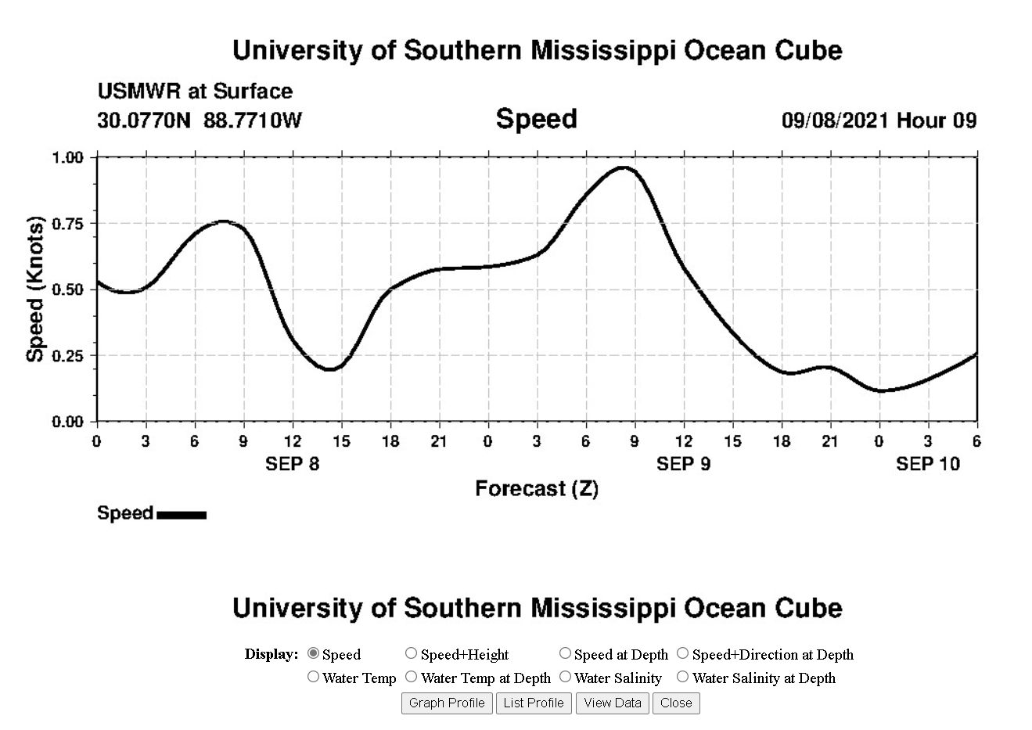

Using shift-click will link to a web site for that reference point. Typically, these are National Data Buoy Center (NDBC) stations and the link is to the NOAA maintained web site for that station.
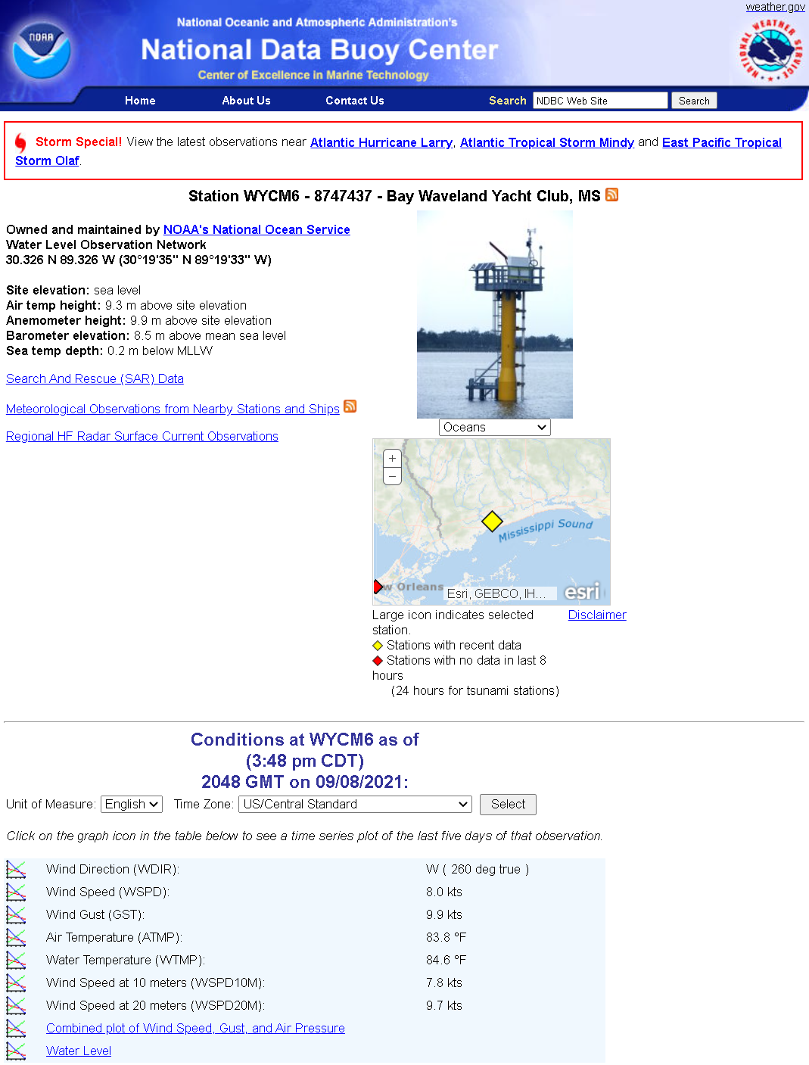

If the Reference Point is the location of USM Instrumentation, the link will open the CUBEnet page associated with the instrumentation at that site to provide the Grafana display of incoming data.

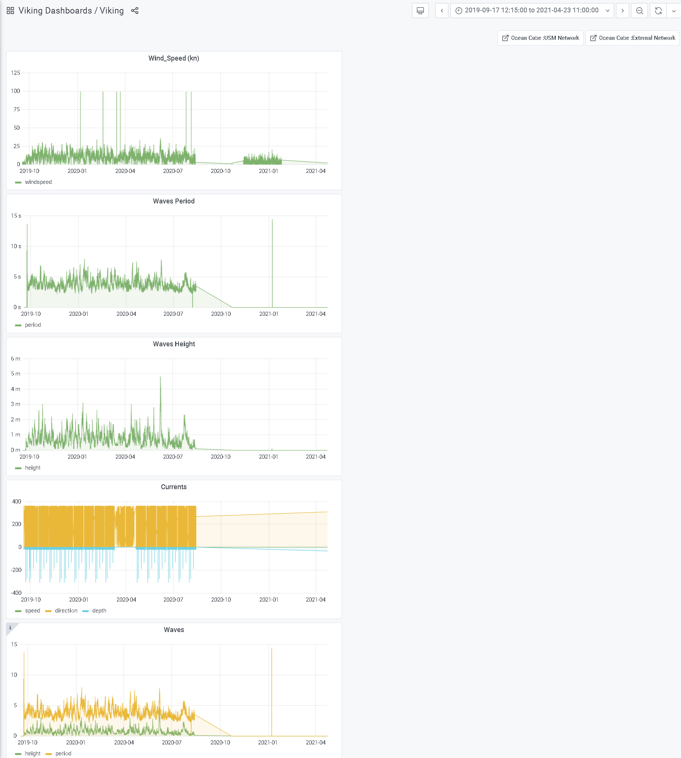

There is currently one high resolution model area that is embedded within the USM test range. The boundaries for this area (approximately 3km by 3km) are visible on the display. The model data is derived from the unstructured data produced by the NGOFS2 model and supports an approximate 130-meter resolution. A click on the area within the boundary launches the 4-D Cube application for the high-resolution model.

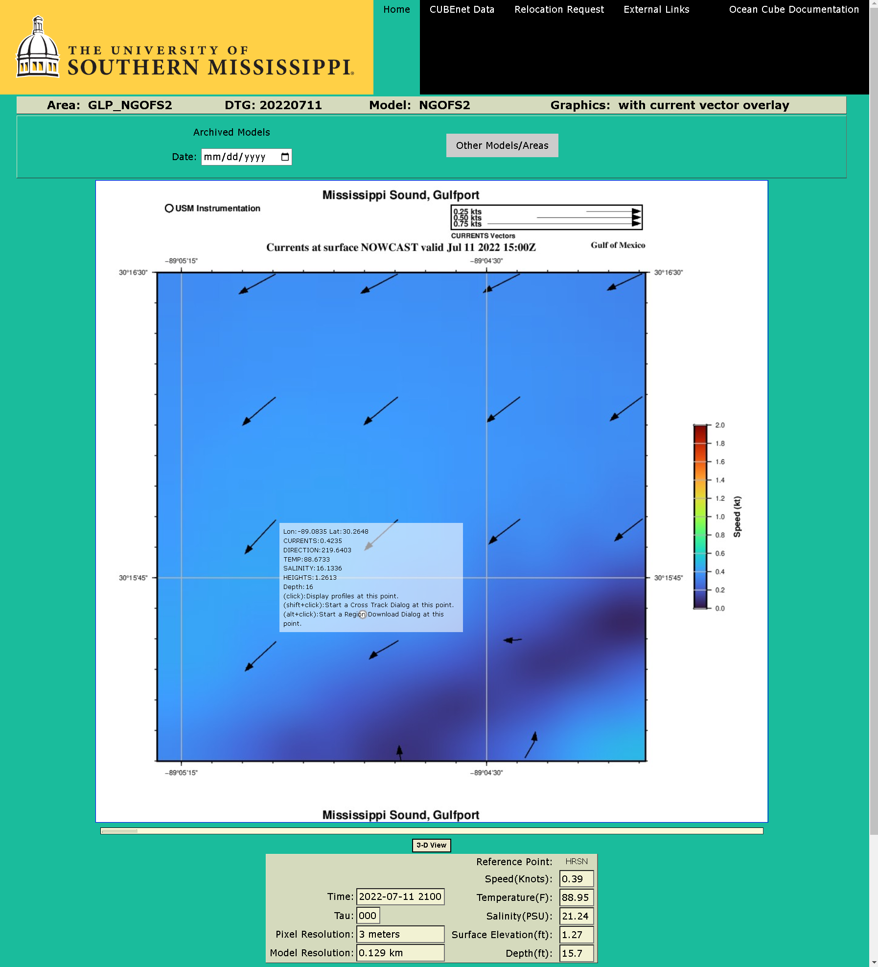

There is the also the capability of displaying track data from sensor vehicles that can be updated with near real-time data. The legend that maps the track color to the vehicle name is in the upper right corner of the image display. When hovering over the track line, the option to download the position data for the vehicle is displayed. A click on these track lines will generate a download the vehicle position data for that track line as a Comma Separated Values (.csv) file.

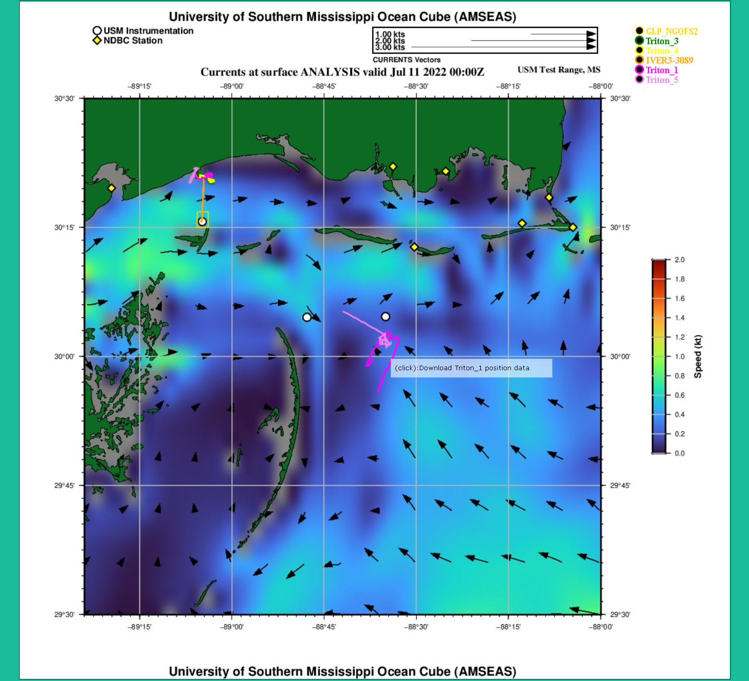

Below is an edit sample of the track line position data file that is downloaded.

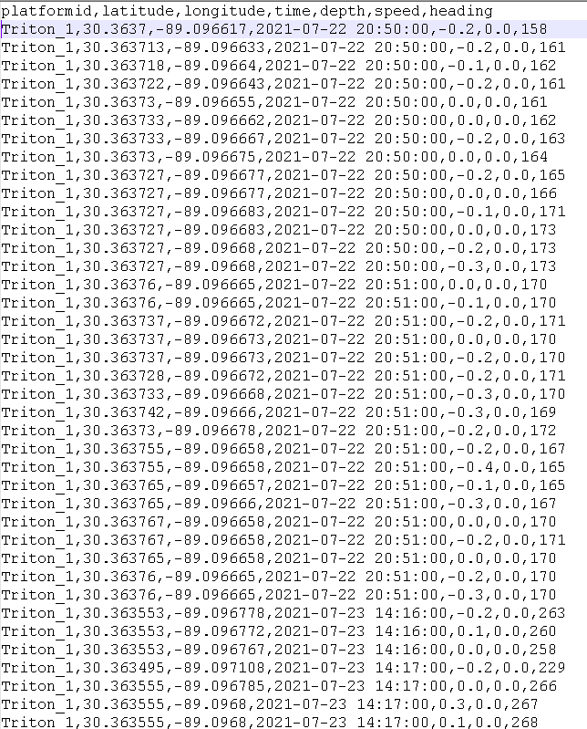

Selecting the 3-D View button below the display allows the user to view all available depth slices for the selected model-parameter simultaneously. Users can rotate the 3-D view using a mouse or trackpad.

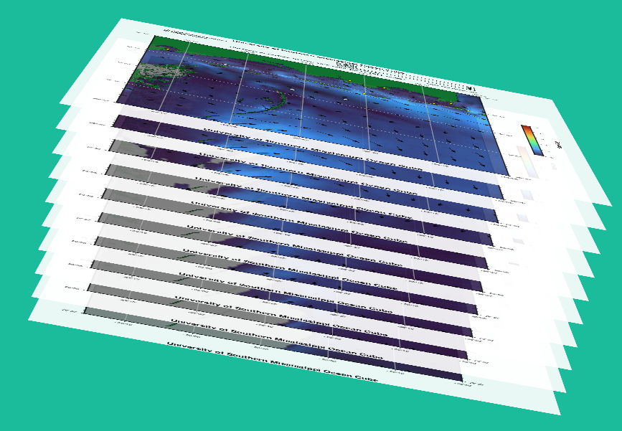

The depth drop-down menu alters the 3-D view so that the selected depth is displayed.

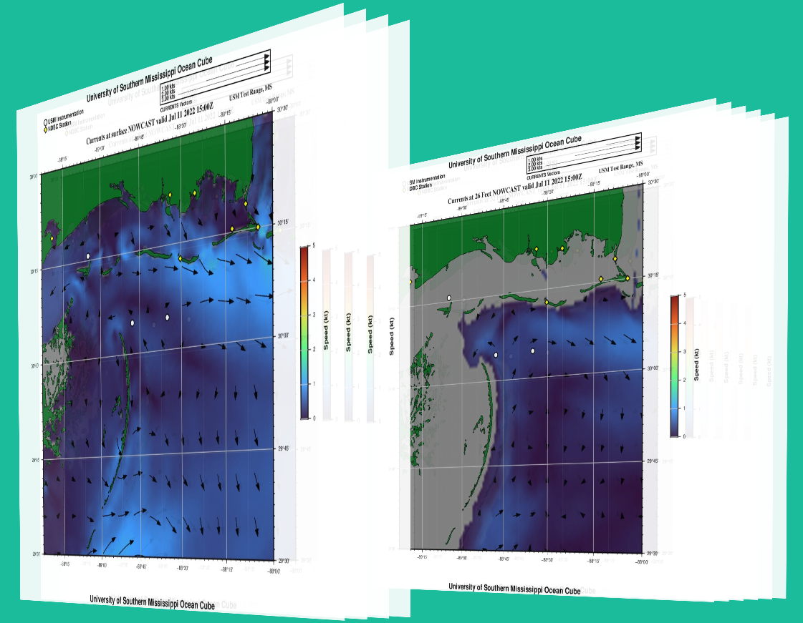

The locations of regional reference points are displayed on the slices. The most recent model estimate at the reference point location is available on the user interface page in tabular form. Users may select a reference by clicking the graphic symbol for the point to view a time series of measurements. Users may also shift-click to obtain data from the reference point’s website.

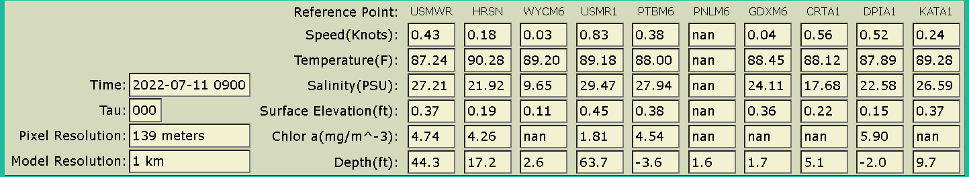

Input Data

With the exception of acoustic transmission loss, all data displayed on the Cube is obtained from external sources chosen to provide trusted and reliable comprehensive coverage of the region. Once received, data/output are geographically extracted and then the Generic Mapping Tool software (GMT) from the University of Hawaii’s School of Earth Science and Technology is used to generate data graphics.

HYDRODYNAMIC OCEAN MODELS

Output from widely used ocean models are extracted and displayed. Differences in model output stem from algorithm differences between models, varying horizontal grid spacing, utilization of differing depth coordinate systems to solve the models, temporal resolution and discrepancies in boundary conditions and inputs. A brief description of each model is provided here as well as source websites in Table XX for more details.

All available observed, nowcast and forecast time steps are obtained from each model.

- HYbrid Coordinate Ocean Model (HYCOM)
HYCOM (Hybrid Coordinate Ocean Model) is the Naval Oceanographic Office’s operational ocean model. HYCOM is named after its hybrid vertical coordinate system that uses the layered continuity equation to transition between sigma, isopycnal and z depth layers. The operational version of HYCOM provides the boundary conditions for the HYCOM experiment GOMu0.04/expt_90.1m000 selected for the CUBE. This HYCOM experiment is run with HYCOM version 2.2.99G-i for the Gulf of Mexico. The solution is calculated with forcing from the Navy Global Environmental Model (NAVGEM) and tidal forcing on 36 vertical layers. Satellite and in situ observations are assimilated using the Navy Coupled Ocean data Assimilation system (NCODA). Each nowcast and forecast is interpolated to a 1/25° horizontal and 40 standard z-level grid for distribution. Further and complete HYCOM documentation can be found at https://www.hycom.org/hycom/documentation .

On July 12, 2022 the following was taken from https://www.hycom.org/hycom/overview :

HYBRID COORDINATE OCEAN MODEL
HYCOM Overview

Traditional vertical coordinate choices [z-level, terrain-following (sigma), isopycnic] are not by themselves optimal everywhere in the ocean, as pointed out by recent model comparison exercises performed in Europe (DYnamics of North Atlantic MOdels - DYNAMO) and in the U.S. (Data Assimilation and Model Evaluation Experiment - DAMEE). Ideally, an ocean general circulation model (OGCM) should (a) retain its water mass characteristics for centuries (a characteristic of isopycnic coordinates), (b) have high vertical resolution in the surface mixed layer (a characteristic of z-level coordinates) for proper representation of thermodynamical and biochemical processes, (c) maintain sufficient vertical resolution in unstratified or weakly-stratified regions of the ocean, and (d) have high vertical resolution in coastal regions (a characteristic of terrain-following coordinates).
The hybrid coordinate is one that is isopycnal in the open, stratified ocean, but smoothly reverts to a terrain-following coordinate in shallow coastal regions, and to z-level coordinates in the mixed layer and/or unstratified seas. The hybrid coordinate extends the geographic range of applicability of traditional isopycnic coordinate circulation models (the basis of the present hybrid code), such as the Miami Isopycnic Coordinate Ocean Model (MICOM) and the Navy Layered Ocean Model (NLOM), toward shallow coastal seas and unstratified parts of the world ocean. The theoretical foundation for implementing such a coordinate was set forth in Bleck and Boudra (1981) and Bleck and Benjamin (1993). In HYCOM, each coordinate surface is assigned a reference isopycnal. The model continually checks whether or not grid points lie on their reference isopycnals and, if not, tries to move them vertically toward the latter. However, the grid points are not allowed to migrate when this would lead to excessive crowding of coordinate surfaces. Thus, in shallow water, vertical grid points are geometrically constrained to remain at a fixed depth while being allowed to join and follow their reference isopycnals over the adjacent deep ocean.
In the mixed layer, grid points are placed vertically so that a smooth transition of each layer interface from an isopycnic to a constant-depth surface occurs where the interface outcrops into the mixed layer. HYCOM therefore behaves like a conventional sigma model in very shallow and/or unstratified oceanic regions, like a z-level coordinate model in the mixed layer or other unstratified regions, and like an isopycnic-coordinate model in stratified regions. In doing so, the model combines the advantages of the different types of coordinates in optimally simulating coastal and open-ocean circulation features. The present procedure of driving high-resolution coastal models (which invariably use fixed vertical grids) with output from a basin-scale isopycnic model can be streamlined, since HYCOM will be able to provide the required near-shore data at fixed depth intervals.
The feasibility of the hybrid coordinate approach for handling both deep and shallow regions, throughout the annual heating/cooling cycle, has recently been demonstrated for a North Atlantic basin configuration by the University of Miami modeling group (Halliwell et al., 1998) in collaboration with the modeling group at the Naval Research Lab. The basin model has performed well both in terms of numerical stability and physical realism in a series of multi-decade simulations. Two vertical cross sections through hybrid model fields, depicting winter and summer conditions respectively, are shown here to illustrate the structure of the hybrid model, the properties of the solutions obtained with it, and the model's handling of seasonal changes in the thermocline, i.e., the point at which the isopycnals become constant depth coordinates. Fig. 1 shows the stratification of the model ocean along a 500 m deep meridional section in the eastern Atlantic in winter. Features to note are the coincidence of layer interfaces and isopycnals in the stratified interior, the vertical orientation of isopycnals in the mixed layer (a feature dictated by the Kraus-Turner paradigm), and the transition of layer interfaces to constant-depth surfaces near the point where they enter the mixed layer. The flattening of the interfaces well below the mixed-layer bottom near 45°N illustrates the point at which the minimum layer-thickness constraint overrides the tendency of a coordinate surface to remain attached to its reference isopycnal. Fig. 2 shows conditions along the same meridional section in summer. At this time, the seasonal thermocline extends upwards to within a few tenths of meters of the surface. This allows several coordinate surfaces at mid to high latitudes, which in Fig. 1 are shown to reside in the mixed layer, to attach themselves to their reference isopycnals. In order to extend the isopycnal coordinate domain upward during the warm season, the minimum layer thickness is allowed to be smaller in summer than in winter.
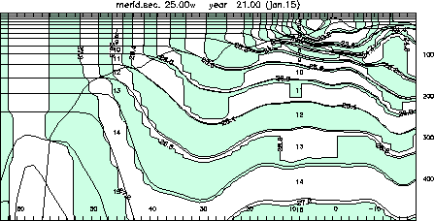
Fig. 1. HYCOM vertical section at 25°W in January of year 21. Shaded field: density. Thin solid lines; layer interfaces. Thick line: mixed-layer depth. Depth range: 500 m. Numbers along bottom indicate latitude. Tick marks at the top and bottom indicate horizontal mesh size.
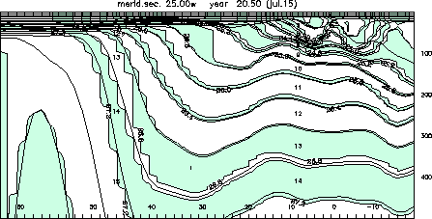
Fig. 2. As in Fig. 1, but for July of year 21.
The capability of assigning additional coordinate surfaces to the oceanic mixed layer gives us the option of replacing the present slab-type Kraus-Turner mixed layer by a more sophisticated closure scheme, such as K-Profile Parameterization (KPP) (Large et al., 1994, 1997). Development of such a new surface boundary scheme is presently underway. The KPP model is particularly attractive for several reasons. It contains improved parameterizations of physical processes in the mixed layer, including non-local effects. It actually calculates the mixing profile from the surface to the bottom of the water column, and thus provides an estimate of diapycnal mixing beneath the mixed layer. It has also been designed to run with relatively low vertical resolution, and is thus substantially more efficient than turbulent closure models. Finally, such a model can simulate the vertical structure of dynamical and thermodynamical variables along with biochemical constituents.
The hybridization work is firmly embedded in MICOM's development effort carried out at the University of Miami and now also at the Los Alamos National Laboratory. The freedom to adjust the vertical spacing of coordinate surfaces in HYCOM will simplify the numerical implementation of some physical processes (mixed layer detrainment, convective adjustment, sea ice modeling, ...) without robbing the model of the basic and numerically efficient layer architecture that is characteristic of layered models throughout most of the ocean's volume.

References:
Bleck, R., and D. Boudra, 1981: Initial testing of a numerical ncean circulation model using a hybrid (quasi-isopycnic) vertical coordinate. J. Phys. Oceanogr., 11, 755-770.
Bleck, R., and S. Benjamin, 1993: Regional weather prediction with a model combining terrain-following and isentropic coordinates. Part I: Model description. Mon. Wea. Rev., 121, 1770-1785.
Halliwell, G., R. Bleck, and E. Chassignet, 1998: Atlantic Ocean simulations performed using a new hybrid-coordinate ccean model. EOS, Trans. AGU, Fall 1998 AGU meeting.
Large, W. G., J. C. Mc Williams, and S. C. Doney, 1994: Oceanic vertical mixing: A review and a model with a nonlocal boundary layer parameterization. Rev. Geophys., 32, 363-403.
Large, W.G., G. Danabasoglu, S.C. Doney, and J.C. McWilliams, 1997: Sensitivity to surface forcing and boundary layer mixing in a global ocean model: Annual-mean climatology. J. Phys. Oceanogr., 27, 2418-2447.

Disclaimer
This is a demonstration product from the HYCOM Consortium and is provided as is. HYCOM Consortium does not warrant or suggest that this data is fit for any particular purpose. Further, neither COAPS nor HYCOM consortium guarantee availability, service updates or timely data delivery.

- AMerican SEAS (AMSEAS)
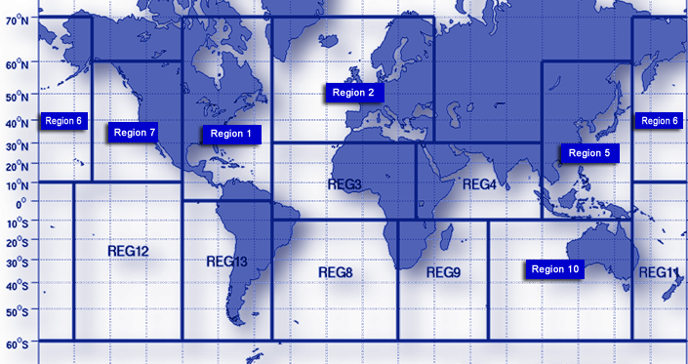
NCOM (Navy Coastal Ocean Model) was the operational global ocean model for the Navy prior to HYCOM. Regional NCOM models are now used by the Fleet Numerical Meteorology and Oceanography Center (FNMOC) and for scientific research. Ocean Cube uses the AMSEAS Regional NCOM model with a domain covering the American Seas region that includes the Gulf of Mexico and Caribbean Sea. AMSEAS produces 96 hours of forecasts at 3-hour intervals updated daily at midnight GMT. The output is interpolated into a 1/30 degree (about 3 km) regularly-spaced grid with 40 vertical levels. The AMSEAS parameters include ocean temperature, salinity, eastward and northward currents and sea surface elevation. As with HYCOM, satellite and in situ observations are assimilated using the Navy Coupled Ocean data Assimilation system (NCODA). Forcing is from the Coupled Ocean/Atmosphere Mesoscale Prediction System (COAMPS) with boundary conditions set by the operational 1/12 degree global HYCOM.
On July 12, 2022 the following was taken from FNMOC Navy Global Hybrid Coordinate Ocean Model | National Centers for Environmental Information (NCEI) (noaa.gov) :

FNMOC Navy Global Hybrid Coordinate Ocean Model

The Fleet Numerical Meteorology and Oceanography Center (FNMOC) global-scale operational ocean prediction system produces daily ocean forecasts based on the Navy Global Hybrid Coordinate Ocean Model (HYCOM). Navy HYCOM is the successor to the Global ​Navy Coastal Ocean Model (NCOM), and provides boundary conditions to Navy regional models such as AMSEAS and USEAST . The system is also run by NOAA, with different atmospheric forcing, as the Global Real-Time Ocean Forecast System (Global RTOFS).
- Data Access
- About

Specifications
Navy Global HYCOM is produced once a day, with a forecast range of 7 days. All input data are assimilated using the NRL-developed Navy Coupled Ocean Data Assimilation (NCODA) system.

Output Data
Variables
Ocean temperature, salinity, eastward and northward currents, elevation
Horizontal Resolution
1/12°
Vertical Resolution
40 standard depth levels
Frequency
Daily, at 00Z
File Format
NetCDF

Input Data
- Satellite altimeter observations
- Satellite and in situ sea surface temperature
- In situ vertical temperature and salinity profiles from XBTs, ARGO floats, and moored buoys
the Navy's NCOM Publications page for additional information on NCOM.

- Northern Gulf of Mexico Operational Forecast System (NGOFS2)
The Northern Gulf of Mexico Operational Forecast System version 2 (NGOFS2) model is run and maintained by NOAA’s Center for Operational Oceanographic Products and Services (CO-OPS). The model is run 4 times daily (03, 09, 15, and 21) and includes 6 hours of nowcast using already received observations and 48 hour of forecasts at 3-hour temporal increments (TAUs). The model is run on an irregularly spaced horizontal grid that allows variable resolution (45 m to 10 km). NGOFS2 runs on 41 vertical sigma layers. The model is interpolated to regularly spaced grids (1 km resolution) for distribution and this regularly spaced grid is the version typically used by CUBEnet. The one exception, is currently the high-resolution model for the GLP_NGOFS2 area that is pictured in a graphic above. In this case the unstructured data available from the NOAA web-site is downloaded and then interpolated into a 129 meter regularly spaced NetCDF formatted grid and processed identically from that point.
On July 12, 2022 the following was taken from https://tidesandcurrents.noaa.gov/ofs/ngofs2/ngofs_info.html:

The Northern Gulf of Mexico Operational Forecast System (NGOFS2)

Oceanographic nowcasts and forecast guidance are scientific predictions about the present and future states of a water body (generally including water levels, currents, water temperature and salinity). These predictions rely on either observed data or forecasts from large-scale numerical models. A nowcast incorporates recent (and often near real-time) observed meteorological, oceanographic, and/or river flow rate data and/or analyzed (e.g. gridded) meteorological and oceanographic products. A nowcast covers the period of time from the recent past (e.g., the past few days) to the present, and it can make predictions for locations where observational data are not available. Forecast guidance incorporates meteorological, oceanographic, and/or river flow rate forecasts and makes predictions about the future states of a water body. A forecast is usually initiated by the state of a nowcast.
- 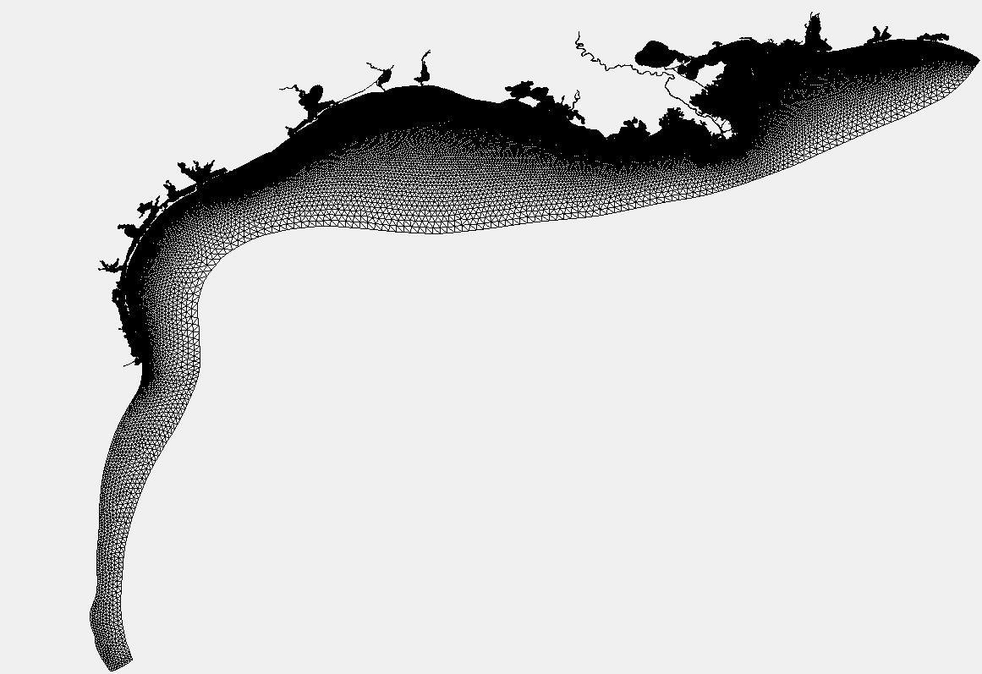
The wind data used to run NGOFS2 are based on the National Weather Service (NWS) nested, high resolution (4 km) North American Mesoscale (NAM) weather prediction model winds (for the nowcast and forecast).
Additionally, NGOFS2 relies on CO-OPS' real-time water level, temperature and salinity observations, NWS Extratropical Storm Surge (ETSS) forecasts, the Advanced CIRCulation Model (ADCIRC) ec2001 tide database, U.S. Geological Survey (USGS) river data, and the Global Real-Time Ocean Forecast System (G-RTOFS).

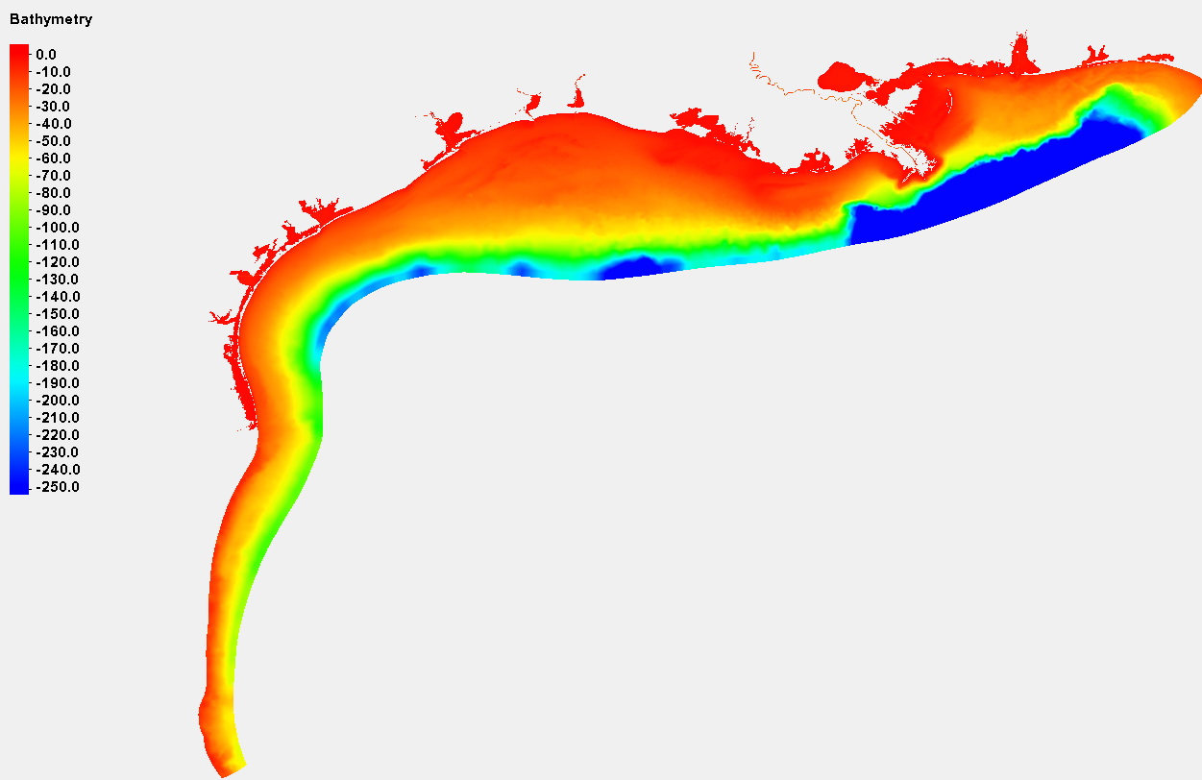

The NGOFS2 grid, arching the open boundary between the coast near Panama City, Florida to the northeast and Veracruz, Mexico to the southwest, has 303,714 nodes and 569,405 elements. Grid resolution ranges from 10 km on the open ocean boundary to approximately 600 m near the coast, indicating the flexibility of the grid size based on bathymetry from the deep ocean to the coast. Additionally, the higher resolution along the navigational channels within bays, the inlets connecting bays with their adjacent coast, the intracoastal waterways, and the narrow tidal creeks, from approximately 45 m to 300 m, well resolves the complicated coastline and geometry, and thus is able to provide the detailed current features. The NGOFS2 grid and spatial extent is indicated above. Note that the greatest resolution of the NGOFS2 grid corresponds with the major bays in the northern Gulf of Mexico. The northern Gulf of Mexico bathymetry is also shown above.
NGOFS runs on NOAA's High Performance Computers (HPC) in a new Coastal Ocean Modeling Framework (COMF) developed by CO-OPS. As a result, NGOFS has direct access to NWS operational meteorological products that it needs to run reliably. Nowcast and forecast guidance cycles are run 4 times a day (every 6 hours).
NGOFS2 output is in NetCDF format. An archive of NGOFS2 NetCDF nowcast and forecast files can be accessed from THREDDS server.
All CO-OPS official real-time products, including nowcast and forecast guidance from NGOFS2 are monitored by the CO-OPS's Continuous Operational Real-Time Monitoring System (CORMS). CORMS provides 24 hour per day, 7 day per week monitoring and quality control of sensors and data in order to ensure the availability, accuracy, and quality of tide, water level, current, and other marine environmental information. CORMS is intended to identify invalid and erroneous data and information before application of the data by real-time and near real-time users.

- Nearshore Wave Prediction System (NWPS)
Unlike the previous models, NWPS is not a single model but exists as a large set of models developed and maintained by the various Weather Forecast Offices (WFOs) throughout the coastal United States. Furthermore, not all WFOs support the same data types or horizontal resolutions. For CUBEnet currently supported areas, the NSPS regional subset are available through the “lix” WFO (Baton Rouge, LA) for the “Mississippi River Delta and the “Mississippi Coast” areas. For the “Alabama Coast” area the data are available from the “mob” WFO (Mobile, AL) and for the “West Florida” area the data are available from the “tbw” WFO (Tampa Bay, FL). All of the CUBEnet NPWS data sources provide full 1.8 km resolution coverage for the respective areas. Higher resolution data (500 meter) were available from the WFOs but did not provide the full coverage needed. All of the NSPS providers included the following parameters: Winds (Speed and Direction), Wave Height, Wave Direction, Wave Period, Swell Height and Surface Elevation. The Baton Rouge WFO additionally provided Surface Currents (Speed and Direction) parameters for areas within its coverage. The data are made available at 4 times daily at the 00, 06, 12 and 18 hour marks but very rarely are all time slots filled daily. All data are downloaded in “grib” format and are converted to NetCDF to be consistent with the CUBEnet processing software.
On July 12, 2022 the following was taken from Nearshore Wave Prediction System (noaa.gov)

Nearshore Wave Prediction System
The Nearshore Wave Prediction System (NWPS) provides on-demand, high-resolution nearshore wave model guidance to U.S. coastal WFOs, triggered in real time by forecast wind grids prepared and submitted by the individual offices. NWPS is maintained and developed by NCEP's Environmental Modeling Center (EMC) in collaboration with a number of Weather Forecast Offices (WFOs), as well as partners at NOAA/NOS, USGS and USACE.
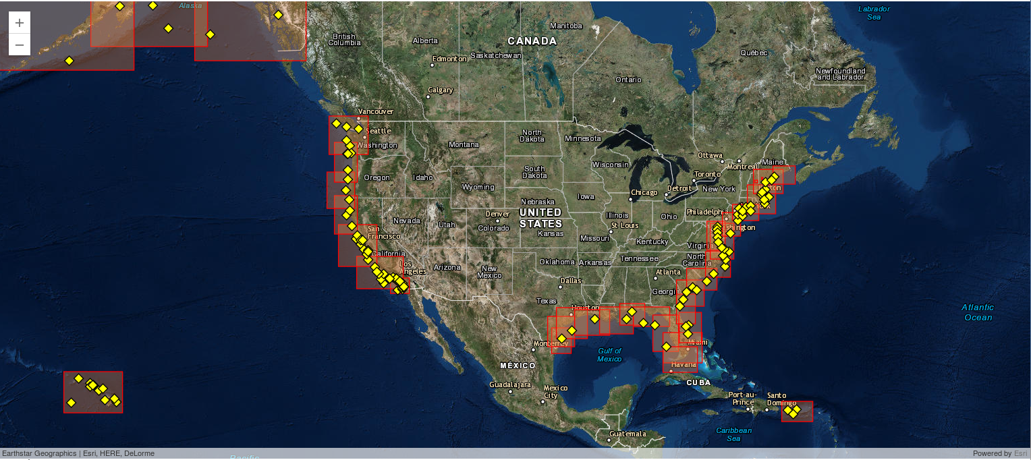
NWPS is driven by forecaster-developed wind grids produced in AWIPS, and wave boundary conditions from the operational WAVEWATCH III model. The nearshore wave model used is SWAN. Wave-current interaction is included using surface currents from the Real-Time Ocean Forecast System (RTOFS-Global). Tides and storm surge are accounted for using the Extratropical Surge and Tide Operational Forecast System (ESTOFS, extratropical conditions), or the probabilistic model P-SURGE (tropical conditions). The computational grids have a nearshore resolution of 1.8 km-500 m. NWPS produces fields of integral wave parameters, wave spectra, and individually tracked wave systems (Gerling-Hanson plots). Experimental rip current and total water level guidance is produced at 5 pilot WFOs.

- Coupled Ocean Atmosphere Wave Sediment Transport (COAWST)
There are several implementations of COAWST model, but CUBEnet uses a specific implementation that is developed and maintained by the University of Southern Mississippi and has significant coverage in the USM Test Range just off of the Mississippi coast.
To help anticipate the potential positive or negative effects the proposed Mid-Breton Sediment Diversion project would have on living marine resources in the Mississippi Sound, the research team at USM developed a coupled modeling framework consisting of a ROMS model, habitat suitability models, and an ecosystem model develop with Ecopath with Ecosim. The Regional Ocean Modeling System (ROMS) is used as the circulation model at the core of an application of the Coupled Ocean Atmosphere Wave Sediment Transport (COAWST) modeling system to the Mississippi Bight. The Mid-Breton Sediment Diversion is incorporated into the model to allow for the flow of freshwater discharge into Breton Sound within the model domain.
The USM COAWST model (msbCOAWST) model is typically run daily and the results of the previous day’s hindcast are made available at about 1500Z. The data are produced in an unstructured format and must be interpolated and placed into a regular grid NetCDF format for processing by CUBEnet software. Based on the unstructured horizontal resolution, the CUBEnet COAWST model currently supports a 230 meter horizontal resolution. To maintain consistency with the other CUBEnet models, the 10 vertical levels used by HYCOM, AMSEAS and NGOFS2 for the Mississippi Coast area are chosen. These are specifically: 0, 2, 4, 6, 8, 10, 12, 15, 20, 25 meters. The parameters generated by COAWST are: Currents (Speed and Direction), Water Temperature, Salinity, Winds (Speed and Direction) and Surface Elevation.
On July 12, 2022, I found this 2019 paper written by the Coastal Marine Hazards and Resources Program (CMHRP): The Coupled Ocean-Atmosphere-Wave-Sediment Transport Modeling System | U.S. Geological Survey (usgs.gov)

The Coupled Ocean-Atmosphere-Wave-Sediment Transport Modeling System

To responsibly manage our coastal resources requires an understanding of the processes responsible for coastal change. The CMHRP developed a Coupled Ocean–Atmosphere–Wave–Sediment Transport (COAWST) modeling system that allows the user to evaluate how different processes such as winds and waves, combined with sediment transport, interact with coastlines to modify them. Users can change model parameters such as the strength and directions of winds, and activate different interactions such as how waves alter ocean currents, to see how the coast might change during extreme events such as hurricanes.

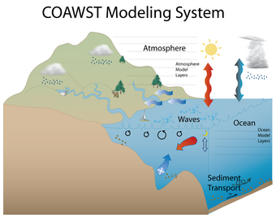

Sources/Usage: Public Domain.
The COAWST modeling system joins an ocean model, an atmosphere model, a wave model, and a sediment transport model for studies of coastal change.
Development of the publicly available, well-tested, expert-supported, and widely accepted COAWST model has already benefited the ocean research community and management in tracking ocean circulation, siting observational equipment, and daily forecasting of water levels, currents, ocean water temperature and salinity, wave heights, and sediment movement along the coast. The model also has a capability to predict the vulnerability of the coasts to natural hazards such as surge, waves, and storm impacts. A key advantage of the COAWST framework is that model runs are archived and publicly accessible. By analyzing this data history, researchers can study trends of storm tracks and ocean conditions and how they change over time.
COAWST is one of several models developed and applied by the CMHRP to predict the response of coastal and marine systems to environmental forcing and evaluate the threat to coastal communities and ecosystems.

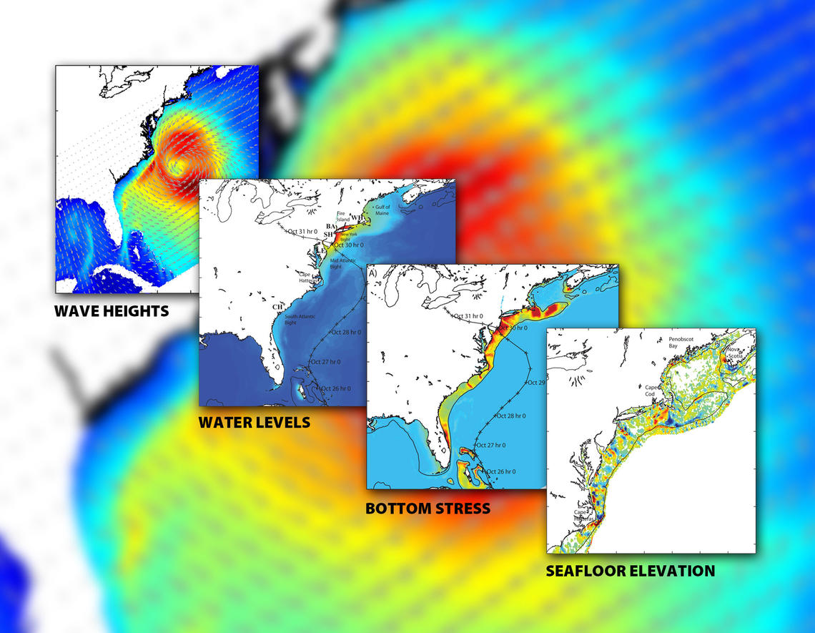

Model Summary:
Name | Source | Horizontal Resolution | Vertical Resolution | Time Step | Forecast
HYCOM | ncss.hycom.org | 3.5 km | 36 z, sigma and isopycnal layers | 3-hour | 120 hours
AMSEAS | www.ncei.noaa.gov | 3 km | 40 z and sigma layers | 3-hour | 96 hours
NGOFS2 | opendap.co-ops.nos.noaa.gov | 1 km  calculated at 45 m – 11 km | 41 sigma layers | 3-hour | 54 hours
NWPS | nomads.ncep.noaa.gov | 1.8 km | Surface | 1-hour | 144 hours
COAWST | 131.95.109.13:8080/thredds | 230 meters | 10 z layers | 1-hour | 24 hours

OTHER

In addition to model solutions, high frequency radar observations, satellite observations, bathymetry, acoustics and mooring observations contribute to the Cube’s mission to provide comprehensive regional coverage.

    - High Frequency Radar Surface Currents
The Cube obtains high frequency radar of current speed and direction from the National Data Buoy Center (NDBC). The currents are measured hourly at 6 km resolution.
On July 12, 2022 the following was taken from HF Radar Surface Currents (noaa.gov):

High Frequency Radar Surface Currents

What is High Frequency (HF) Radar?
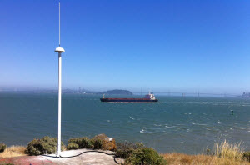
HF radar systems utilize high frequency radio waves to measure the surface currents in the coastal ocean. Radar antennas (typically in pairs) are positioned on shore and can measure surface currents (the top 1-2 m of the water column) up to 200 km away with resolutions ranging from 500 m to 6 km depending on the radar frequency. The observations of the currents are usually 1-hour averages displayed in near real time. There are over 100 HF Radar systems presently operating throughout the coastal United States. For more information on HF Radar technology and data please see the U.S. Integrated Ocean Observing System (IOOS) HF Radar site.

What HF Radar Data does CO-OPS display?
The CO-OPS HF Radar Surface Current product displays both near real time surface current observations and surface tidal current predictions. Presently, CO-OPS displays observations and predictions from San Francisco Bay, Chesapeake Bay and New York Harbor though additional locations may be added in the future. For observations from other HF Radar locations please see the National Network site..

Observations
The observed HF Radar currents are hourly averages of the surface current speed and direction for the past 48 hours. The time average typically occurs centered on the hour - for example, data with a timestamp of 12:00 indicates that the observations were collected and averaged from 11:30 to 12:30. Each map grid point represents the average current over a spatial area depending on the HF Radar resolution (e.g. at Chesapeake Bay each point represents an area of 2 km x 2 km). These data are collected from the National Network and quality control is performed prior to CO-OPS receiving the data. CO-OPS does not archive data beyond 48 hours old. To view archived data please see the National Network site or the National Data Buoy Center (NDBC) site.
.

Tidal Current Predictions
The predictions shown at each grid point are the predictions of the speed and direction of the tidal component of the surface current at that location. The predictions were calculated by performing a harmonic analysis for one year of the observed HF Radar surface currents at each grid location. These values represent only the tidal portion of the surface current - other factors that influence the currents (e.g. wind, water density differences) are not included in this prediction.

Level of Uncertainty in HF Radar Observations and Predictions
Both the HF Radar observed and predicted surface currents have some amount of uncertainty in the accuracy of the values presented.
For the observed surface currents, although the precise amount of error is difficult to quantify, HF Radar data is generally expected to be accurate to within 10 cm/s of current speed and 10 degrees of current direction. It is important to note, that the presented values are spatial and time averages - so that they may not be representative of the currents of a specific point within a grid cell (particularly near shore) or of an instant in time during the observed hourly period.
Uncertainty in the accuracy of the predictions is much greater. For most locations the primary source of differences between the predicted and observed surface current will be wind forcing (though water density differences can also be important). Depending on local meteorological conditions the actual speed and direction of the surface current at a particular location can be dramatically different than predicted.

Differences from NOAA Tidal Current Tables
It is expected that there will be differences between the HF Radar Surface Current predictions and the current predictions in the NOAA Tidal Current Tables (TCTs). There are numerous reasons for these differences including: The predictions in the TCTs are from data collected at depth, while the HF Radar predictions are from data collected at the surface; The predictions in the TCTs are collected at a single point, whereas the HF Radar predictions are spatial averages over kilometer(s); and the predictions in the TCTs are typically based on 6 minute averages of the currents, whereas the HF Radar predictions are based on hourly averages.

    - Satellite Observations
- VIIRS-Chlorophyll
Satellite derived chlorophyll (surface only) is obtained from CoastWatch and displayed when atmospheric conditions allow at least 10% coverage in the Cube region. The chlorophyll estimates are made via the OCL3 equation to calculate chlorophyll concentration from water leaving radiance. The Cube displays surface chlorophyll derived from measurements made by the Visible Infrared Imaging Radiometer Suite (VIIRS) on board the Suomi National Polar-orbiting Partnership (S-NPP) satellite.
On July 12, 2022 the following was taken from the Description tab at https://coastwatch.noaa.gov/cw/satellite-data-products/ocean-color/near-real-time/viirs-multi-sensor-daily-merge.html :

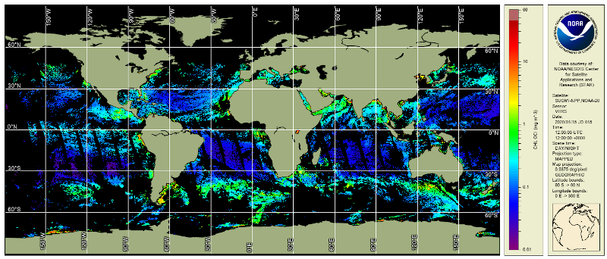

Ocean Color Level 3 VIIRS multi-sensor, daily, global, merge is produced through NOAA Multi-Sensor Level 1 to Level 2 processing system (MSL12). Parameters from this product suite include chlorophyll-a concentration (pictured above for 15 January 2020) and diffuse attenuation coefficients (K_{d(490)} and K_{d(PAR)} (not shown).
Ocean Color satellite sensors measure visible light at specific wavelengths which leaves the surface of the ocean and arrives at the top of the atmosphere where the sensor is located. From these visible spectral measurements, along with simultaneous measurements in the near infrared (NIR) and the short wave infrared (SWIR) wavelengths, the color of the ocean, or normalized water leaving radiances (nL_{w}), can be calculated. Then, the nL_{w}s are used to derive other ocean properties such as the concentration of chlorophyll-a (chlor-a or sometimes chl, which is the green pigment responsible for photosynthesis and therefore an indicator of the amount of phytoplankton biomass in the ocean water) and the coefficient of extinction for downwelling irradiance (K_{d(PAR)} and K_{d(490)} which are related to water clarity).

The ocean color datasets described here are from the Visible and Infrared Imaging Radiometer Suite (VIIRS) sensor aboard the Suomi-NPP satellite (SNPP) which was launched in November 2011 and also aboard the NOAA-20 satellite launched in November 2017. NOAA ocean color data are processed using NOAA Multi-Sensor Level 1 to Level 2 processing system (MSL12) developed by the NOAA/STAR Ocean Color Team [Wang et al.(link is external), 2013].

An excerpt from the EOS article by Mikelsons et al., 2019(link is external) explains the approach to the Level-3, multi-sensor merged, global, daily data product served here by CoastWatch at ~4 km spatial resolution in NetCDF format. "SNPP and NOAA-20 operate along the same Sun-synchronous polar orbit that crosses the equator at about 13:30 local time—both satellites travel around Earth from pole to pole in such a way that they observe the same areas at about the same time of day, no matter the season. There is about a 50-minute delay between the paths of NOAA-20 and SNPP, so NOAA-20’s path runs between two adjacent SNPP orbital paths and vice versa. Thus, the overlap of the spatial coverages in the two VIIRS sensors automatically fills each instrument’s data gaps [Mikelsons and Wang(link is external), 2019]. In addition, ocean color data from the VIIRS SNPP and NOAA-20 have the same spatial and temporal resolution, and these data are processed using the same algorithm and software package (i.e., MSL12). Therefore, the statistics of their ocean color products are very similar, and the data can be merged into a global 9-kilometer resolution data set directly without adjustment [Liu and Wang(link is external), 2019]."

These multi-sensor daily merged products are derived from MSL12 v1.3 for both SNPP plus NOAA-20. The chlorophyll-a algorithm is OCI [Hu et al., 2012(link is external); Wang and Son, 2016(link is external)].

  - GOES-16 (Wind Speed and Sea Surface Temperature)
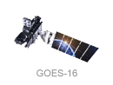
Satellite derived wind speed and Sea Surface Temperature (SST) are obtained from CoastWatch ERDDAP server and displayed similar to the HF-RADAR observations with hourly data (TAUs) collected over the previous 48 hours. The data resolution is at 0.02 degrees or about 2.2 kilometers. Data is made available hourly with about a 6-hour delay from the actual observation.
On July 12, 2022 the following was taken from GHRSST NOAA/STAR GOES-16 ABI L3C America Region SST v2.70 dataset in GDS2 | PO.DAAC / JPL / NASA

GHRSST NOAA/STAR GOES-16 ABI L3C America Region SST v2.70 dataset in GDS2
(ABI_G16-STAR-L3C-v2.70)
Version | 2.70
Processing Level | 3
Start/Stop Date | 2017-Dec-15 to Present
Short Name | ABI_G16-STAR-L3C-v2.70
Description | The ACSPO G16/ABI L3C (Level 3 Collated) product is a gridded version of the ACSPO G16/ABI L2P product available at https://podaac.jpl.nasa.gov/dataset/ABI_G16-STAR-L2P-v2.70. The L3C output files are 1hr granules in netCDF4 format, compliant with the GHRSST Data Specification version 2 (GDS2). There are 24 granules per 24hr interval, with a total data volume of 0.2GB/day. Fill values are reported at all invalid pixels, including pixels with 5 km inland. For each valid water pixel (defined as ocean, sea, lake or river, and up to 5 km inland), the following layers are reported: SSTs, ACSPO clear-sky mask (ACSM; provided in each grid as part of l2p_flags, which also includes day/night, land, ice, twilight, and glint flags), NCEP wind speed, and ACSPO SST minus reference (Canadian Met Centre 0.1deg L4 SST; available at https://podaac.jpl.nasa.gov/dataset/CMC0.1deg-CMC-L4-GLOB-v3.0). All valid SSTs in L3C are recommended for users. Per GDS2 specifications, two additional Sensor-Specific Error Statistics layers (SSES bias and standard deviation) are reported in each pixel with valid SST. The ACSPO VIIRS L3U product is monitored and validated against iQuam in situ data (Xu and Ignatov, 2014) in SQUAM (Dash et al, 2010).
DOI | 10.5067/GHG16-3UO27
Measurement | OCEANS > OCEAN TEMPERATURE > SEA SURFACE TEMPERATURE
Platform/Sensor | GOES-16  /  ABI
Project | Group for High Resolution Sea Surface Temperature (GHRSST)
Data Provider | Publisher: PO.DAAC  Creator: NOAA/NESDIS/STAR  Release Place: Camp Springs, MD (USA)  Release Date: 2019-May-30  Resource: https://www.star.nesdis.noaa.gov/star/index.php
Format | netCDF-4
Keyword(s) | GHRSST, SST, GOES16, G16, ABI, OSPO, STAR, v2.70, ACSPO
Questions related to this dataset? Contact podaac@podaac.jpl.nasa.gov

- Bathymetry
The bathymetry is a static netcdf file residing on the ocean cube server with data derived from the NOAA Coastal Relief Model (CRM) Vol. 4.
On Sept 13, 2021 the following was taken from https://www.ncei.noaa.gov/metadata/geoportal/rest/metadata/item/gov.noaa.ngdc.mgg.dem:309/html :

U.S. Coastal Relief Model Vol.4 - Central Gulf of Mexico

NGDC's U.S. Coastal Relief Model (CRM) provides the first comprehensive view of the U.S. coastal zone integrating offshore bathymetry with land topography into a seamless representation of the coast. The CRM spans the U.S. East and West Coasts, the northern coast of the Gulf of Mexico, Puerto Rico, and Hawaii, reaching out to, and in places even beyond, the continental slope. Bathymetric and topographic data sources include: NGDC's NOS hydrographic surveys, multibeam bathymetry, and trackline bathymetry; the U.S. Geological Survey (USGS); and other federal government agencies and academic institutions. Bathymetric contours from the International Bathymetric Chart of the Caribbean Sea and the Gulf of Mexico project were also used. Digital elevation models (DEMs) of the Great Lakes, Southern Alaska, and high-resolution DEMs of U.S. coastal communities and territories are also available.

- Acoustics
The BELLHOP beam tracing model is run on demand by the user to predict transmission loss across a selected transect. A Fortran-based version of the BELLHOP software is housed on a USM server. The input to the software includes bathymetry, model estimates of sound speed and source depth and frequency.
On July 12, 2022 the following was taken from http://www.siplab.fct.ualg.pt/models/bellhop/manual/node2.html :

Introduction
Bellhop is a highly efficient ray tracing program, written in Fortran by Michael Porter as part of the Acoustic Toolbox (available at the website of the Ocean Acoustic Library). Bellhop is designed in order to perform two-dimensional acoustic ray tracing for a given sound speed profile c(z) or a given sound speed field c(r, z), in ocean waveguides with flat or variable absorbing boundaries. Output options include ray coordinates, travel time, amplitude, eigenrays, acoustic pressure or transmission loss (either coherent, incoherent or semi-coherent). The calculation of acoustic pressure is based on the theory of Gaussian beams [1, 2], which can be applied using different approximations, namely:
• geometric beams (the default option) [3];
• beams with ray-centered coordinates;
• beams with Cartesian coordinates;
• Gaussian ray bundless approximation [4].

References
[1] Porter M.B. and Bucker H.P. Gaussian beam tracing for computing ocean acoustic fields. J. Acoust. Soc. America, 82(4):1349–1359, 1987.
[2] Jensen F., Kuperman W., Porter M., and Schmidt H. Computational Ocean Acoustics. AIP Series in Modern Acoustics and Signal Processing, New York, 1994.
[3] Porter M. B. and Liu Y-C. Finite-Element Ray Tracing. In Theoretical and Computational Acoustics, Vol. 2, World Scientific Publishing Co., 1994.
[4] Weinberg H. and Keenan R.E. Gaussian ray bundless for modeling highfrequency propagation loss under shallow-water conditions. J. Acoust. Soc. America, 100(3):1421–1431, September 1996.
[5] Porter M. The KRAKEN normal mode program. SACLANT UNDERSEA RESEARCH (memorandum), San Bartolomeo, Italy, 1991.

- In Situ Moorings/Reference Points
Regional reference point locations are mapped to model displays. At each location, the model estimate for that reference point is provided. The Cube does not download these data directly. To obtain reference point data, a link to the associated website for the reference point is provided on the displayed map. Below is a sample of reference points used in the USM test range.

Name | Source | Type | Measurements  Available | Frequency
USMR1 | USM Instruments | Viking | CTD, currents, waves, meteorology | 15 minute
WYCM6 | ndbc.noaa.gov | station | water level, meteorological | 6 minute
USMWR | USM Instruments | WaveRider | CTD, currents, waves | 15 minute
PTBM6 | ndbc.noaa.gov | buoy | INACTIVE | INACTIVE
PNLM6 | ndbc.noaa.gov | station | water temperature, water level, meteorological | 6 minute
GDXM6 | ndbc.noaa.gov | station | INACTIVE | INACTIVE
CRTA1 | ndbc.noaa.gov | station | meteorological | 15 minute
DPIA1 | ndbc.noaa.gov | station | water temperature, salinity, oxygen, turbidity and meteorological | 30 minute
KATA1 | ndbc.noaa.gov | station | meteorological | hourly

Other Summary
Name | Source | Horizontal Resolution | Vertical Resolution | Frequency
RADAR | hfradar.ndbc.noaa.gov | 6 km | surface | hourly
SNPP-VIIRS | coastwatch.noaa.gov | 750 m | integrated surface | daily  (when at least 10% of area is available)
GOES-16 | coastwatch.pfeg.noaa.gov | 2.2 km | surface | hourly
Bathymetry | ngdc.noaa.gov | 154 m | bottom depth | historic
BELLHOP | Cube server |  |  | on demand
Reference Points | Owner Specific | Single Point | variable | Owner Specific

External Links
The CUBEnet banner includes the tab “External Links” that provides continuously updated links to data sources, regional background and relevant complementary data. As of this printing, the links include:

National Data Buoy Center (Buoy Data/CMAN)
NOAA Northern Gulf of Mexico Operational Forecast System (NGOFS)
NOAA ERDAP AMSEAS Make a Graph
Mississippi Sound and Approaches (Chart 11373 - OceanGrafix.com)
BOEM Northern Gulf of Mexico Bathymetry Grid from 3D Seismic
Gulf of Mexico Coastal Ocean Observing System Data Portal
Gulf of Mexico Coastal Ocean Observing System Gliders:GANDALF
Gulf of Mexico Coastal Ocean Observing System Gliders:GulfHUB
IOOS EDS Model Viewer

